

From Barely Surviving to Truly Thriving
Election Campaign Pack

MARCH 2026

Page of Contents
Introduction 2
Why This Election Matters for Disabled People in Wales 2
What This Campaign Pack Is For 3
2026 Senedd Election Timeline 4
Our Five Calls for Change – At a Glance 5
The Commitment Card 8
Member’s Checklist 11
Template Letters 12
DPO Template Letter 13
Individuals Template Letter 15
Reporting Candidates Responses 16
What to send us? 16
Stay Connected 17

Introduction
Disabled people in Wales have the right not just to survive, but to truly thrive.
The From Barely Surviving to Truly Thriving Manifesto sets out five clear Calls for Change that reflect the priorities and lived experiences of Disabled people across Wales. This manifesto has been developed in collaboration with our member DPOs, our internal policy working group and individual disabled people whose experiences are central to shaping its vision and the priorities.
This manifesto is more than a document. It is a call to political leadership, accountability and action.
You can read the full Manifesto in English, Welsh, EasyRead and BSL here: https://www.disabilitywales.org/from-barely-surviving-to-truly-thriving-disabled-peoples-manifesto-2026-2031/

Why This Election Matters for Disabled People in Wales
The outcome of the 2026 Senedd Election will shape the next five years of legislation, policy and public spending in Wales.
Decisions made in the Senedd Chamber and by the next Welsh Government will affect disabled people’s lives. This campaign pack aims to inform our members about our five Manifesto calls to action and how you can support us.
This election will also take place under a new electoral system. Wales will be divided into 16 larger constituencies, with multiple Members elected in each area.
You can learn more about the new system at: https://senedd.wales/how-we-work/our-role/senedd-election-and-member-changes/
You can use https://new.wales/ to:
- Find out which constituency you are in
- See which candidates are standing in your area
- Understand how the new voting system works
This matters because Disabled people make up one fifth of the Welsh population and it is vital that we engage with the candidates who are seeking to represent us in the Senedd.
To find out more information on how to register to vote, apply for a postal vote, or access support to vote, visit: https://www.gov.uk/register-to-vote

What This Campaign Pack Is For

This pack has been created to help you:
- Understand the five Calls for Change
- Engage with local candidates
- Ask informed questions
- Secure public commitments
- Share the manifesto within your networks
- Help build collective political momentum
It provides practical tools, template letters, messaging guidance and information about how to report candidate responses back to Disability Wales.

2026 Senedd Elections Timeline

- 27 March - Last day of Senedd business.

- 30 March - Official notice of election published (confirms polling date and nomination deadlines).
- 8 April - Dissolution of the Senedd.

- 9 April (4pm) - Deadline for candidate nominations.
- 10 April (4pm) - Publication of final list of candidates standing in each constituency.
- 20 April - Deadline to register to vote.
- 21 April - Deadline to apply for:
- Postal vote
- Postal proxy vote
- Changes to existing postal or proxy votes
- 28 April (5pm) - Deadline to apply for a proxy vote.
- 7 May (7am–10pm) - Polling Day.
- 7 May (5pm) - Deadline to:
- Apply for a replacement for lost or spoilt postal votes
- Apply for an emergency proxy vote
- 8 May - Votes counted.
- 28 May - Deadline for the first meeting of the Seventh Senedd.
- 3 June - Deadline for nomination of the First Minister.

Our Five Calls for Change – At a Glance

The five Calls for Change set out the core priorities in DW’s Manifesto From Barely Surviving to Truly Thriving.
Call 1: Incorporate the UNCRDP into Welsh Law
Make disabled people’s rights legally enforceable by embedding the UN Convention on the Rights of Disabled People into Welsh legislation.
Call 2: Deliver a Robust Disabled People’s Rights Plan
Commit to a long-term, cross-party strategy co-produced with Disabled People’s Organisations (DPOs), backed by funding and clear accountability for delivery, including the appointment of a Minister for Disabled People.
Call 3: Champion the Leadership of Disabled People
Support disabled leaders in public life, including representation in decision-making, policy development and properly resourcing the work of Disabled People’s Organisations.
Call 4: Guarantee the Right to Independent Living
Reform care, housing and health systems to prioritise dignity, choice and accessibility. The call includes ending institutionalisation and promoting full inclusion.
Call 5: Devolve Welfare and Benefits to Wales
Create a fair, co-produced Welsh benefits system that reflects disabled peoples lived experiences and supports financial security and employment.
Downloadable Designed Version
A Social Firms Wales designed PNG version of the “At a Glance” document is available on the next page:

At a Glance

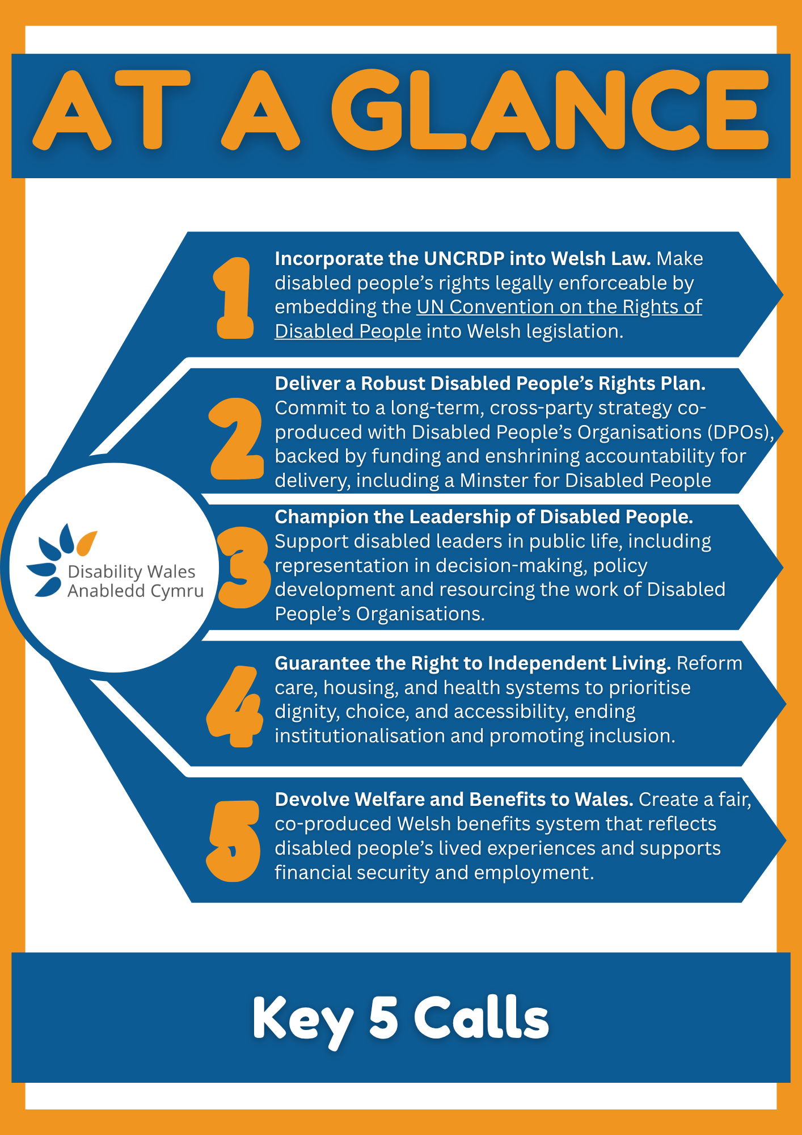

The Commitment Card
Disability Wales is inviting all political parties and individual candidates standing in the 2026 Senedd election to confirm their position on the Five Calls for Change.
Candidates are asked to indicate whether they:
- Commit
- Are Neutral
- Oppose
each of the Five Calls via a short online Microsoft Form. The form can be accessed here: https://forms.office.com/e/Xy3tREzPXh
All responses that are received are published and reflected in the Manifesto Commitment Card. Where no response has been received, this is clearly indicated.
The following positions reflect formal responses provided to Disability Wales to date.
Call 1 - Incorporate the UNCRDP into Welsh Law
- Plaid Cymru: Commit
- Welsh Labour: Commit
- Welsh Conservatives: Commit
- Welsh Liberal Democrats: Commit
- Green Party: Commit
- Reform: No response to date
Call 2 - Deliver a Robust, Long-term Disabled People’s Rights Plan
- Plaid Cymru: Commit
- Welsh Labour: Commit
- Welsh Conservatives: Commit
- Welsh Liberal Democrats: Commit
- Green Party: Commit
- Reform: No response to date
Call 3 - Champion Disabled Leadership and Governance
- Plaid Cymru: Commit
- Welsh Labour: Commit
- Welsh Conservatives: Commit
- Welsh Liberal Democrats: Commit
- Green Party: Commit
- Reform: No response to date
Call 4 - Guarantee the Right to Independent Living
- Plaid Cymru: Commit
- Welsh Labour: Commit
- Welsh Conservatives: Commit
- Welsh Liberal Democrats: Commit
- Green Party: Commit
- Reform: No response to date
Call 5 - Devolve Welfare and Benefits to Wales
- Plaid Cymru: Commit
- Welsh Labour: Commit
- Welsh Conservatives: Oppose*
- Welsh Liberal Democrats: Oppose
- Green Party: Neutral
- Reform: No response to date
*The Welsh Conservatives have confirmed that they do not support the devolution of welfare and benefits to Wales. They have provided additional clarification outlining areas where they support reform within the existing UK-wide framework. This clarification is reflected in the Commitment Card.
Tracking Candidate Responses
Disability Wales is currently contacting individual candidates across all constituencies and inviting them to confirm their position via the Microsoft Form. We would like your help with getting these responses. Please ask your candidates to respond to these 5 calls.
Candidate responses will be tracked and published throughout the election period. Members will be kept updated as new commitments are received.
Transparency enables informed voting.

Downloadable Designed Version
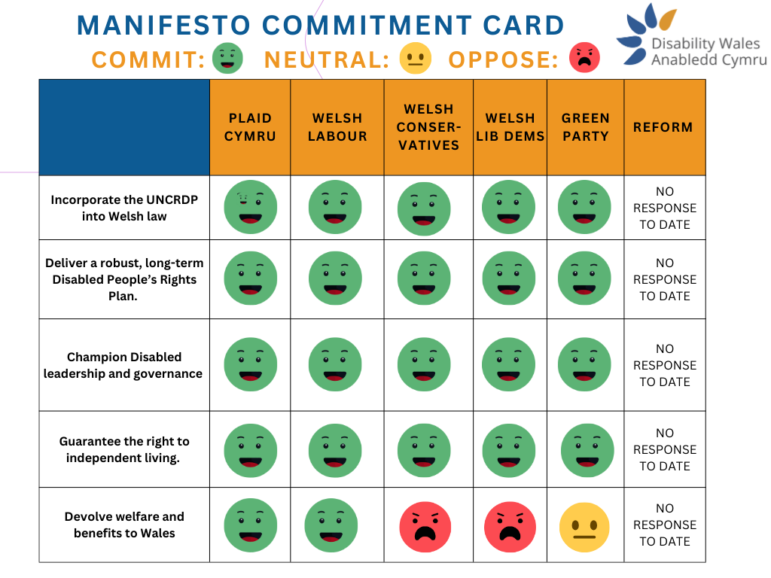
A Disability Wales designed PNG version of the Commitment Card

Members Checklist

What can you do? Make your candidates aware and ask them to commit to our 5 Manifesto Calls!
Contact your candidates. You can download our draft letter to help write to all the candidates in your area. Make them aware of our 5 calls and ask them to pledge to support their disabled constituents.
Share it with your friends!
- Share our Manifesto with your friends
- Encourage them to send letters to their constituency candidates
Get on social media!
- Get out the key messages
- Share the manifesto
- Spread the word about our commitment card
- Follow Disability Wales on Facebook, Bluesky, Instagram and LinkedIn (@disabilitywales) and
- Support our posts about the Manifesto and upcoming Senedd elections.
Get registered to vote!
- Make sure that you are registered to vote in the Senedd Elections. Your vote matters. We need every disabled person in Wales to use their vote to fight for the issues that impact our lives.
- Get your friends, your family, your neighbours, your co-workers, get everyone registered to vote!
- You can register to vote here: https://www.gov.uk/register-to-vote
Manifesto checklist:
- Have you contacted your local candidates?
- Have you shared the manifesto and the letter with your friends and family?
- Have you shared messages on social media?
- Have you registered to vote?
- Have you reminded family and friends to register to vote?

Template Letters
To support engagement with candidates, Disability Wales has developed two template letters:
- One for Disabled People’s Organisations (DPOs)
- One for individual Disabled people and supporters
The templates are designed to help you contact candidates in your constituency, outline the Five Calls for Change, and ask them to confirm their position.
You can adapt the wording to reflect your own experiences, priorities or organisational voice.

DPO Template Letter
Dear [Candidate Name],
I am writing on behalf of [Organisation Name], a Disabled People’s Organisation representing disabled people in [area/community].
As a DPO rooted in the Social Model of Disability, we are asking all candidates standing in [Constituency/Region] to commit to Disability Wales’ Disabled People’s Manifesto From Barely Surviving to Truly Thriving.
Around 1 in 5 people in Wales are disabled. Yet many disabled people continue to feel ignored, excluded, and shut out of decision-making processes that shape our lives.
With ongoing threats to social security support, including PIP and Universal Credit, and continued barriers across housing, health, transport and employment, it is more important than ever that candidates clearly state where they stand on disabled people’s rights.
Disability Wales’ manifesto, co-produced by disabled people for disabled people, calls for five key commitments:
- Incorporating the United Nations Convention on the Rights of Disabled People into Welsh Law
- Delivering a robust, long-term Disabled People’s Rights Plan, including a Minister for Disabled People and sustained funding for Disabled People’s Organisations
- Championing Disabled People in leadership and governance
- Guaranteeing the right to Independent Living, with reform across care, housing and health systems
- Devolving welfare and benefits to Wales, creating a fair, dignified, co-produced system aligned with the Social Model of Disability
As a Welsh DPO, we are also asking you to consider our own priorities for disabled people in our Manifesto, which are outlined in the attached document. We would welcome your response to both the national manifesto and our priorities.
Can we count on you to stand with disabled people and commit to these calls for change?
To enable Disability Wales to track candidate commitments across Wales, please complete the commitment card here:
https://forms.office.com/e/Xy3tREzPXh
We look forward to your response and would welcome the opportunity to meet to discuss these issues further.
Yours sincerely,
[Name], [Role]
[Organisation Name]

Individuals Template Letter

Dear [Candidate] for [Constituency/ Region]
It is time to listen to disabled people in Wales and support our mission to move from #BarelySurvivingToTrulyThriving
Around 1 in 5 people in Wales are disabled, but still Disability Wales research has shown that many disabled people feel ignored, shut out and forgotten by their representatives.
With the recent threats to PIP and Universal Credit. It is more important than ever that disabled people in Wales are listened to and that our rights are protected and implemented.
This is why I am asking you to commit to Disability Wales’ Disabled People’s Manifesto.
“From Barely Thriving to Truly Thriving” was coproduced by disabled people, for disabled people and is calling for key commitments to make Wales a better place for us all to live.
We are asking to you to commit to:
- Incorporating the United Nations Convention on the Rights of Disabled People into Welsh Law
- Deliver a Robust, long term Disabled People’s Rights Plan. Including a Minister for Disabled People and Sustained Funding for Disabled People’s Organisations (DPO’s)
- Champion Disabled People in Leadership and Governance
- Guarantee the Right to Independent Living, with reform across care, housing, and health systems.
- Devolve welfare and benefits to Wales. Creating a fair, dignified, co-produced system aligned with the Social Model of Disability
Can I count on you to stand up for disabled people and bring us our rights so that we can move from #BarelySurvivingToTrulyThriving?
To allow us to track which of our calls candidates commit to, please complete our commitment card tracker here: https://forms.office.com/e/Xy3tREzPXh
Thank you,
[Constituent Name]

Reporting Candidates Responses

Tracking candidate responses is central to ensuring transparency and accountability throughout the election period.
If you contact a candidate whether by email, letter, social media, at a public meeting, or during canvassing, please share their response with Disability Wales.
This includes conversations that take place:
- On the doorstep
- At community events
- At hustings
- During campaign visits
- At street stalls or public engagements

What to send us?
Please forward:
- Written responses from candidates
- Screenshots of social media replies
- Confirmation of signed pledges
- Notes from meetings
- Notes from doorstep or canvassing conversations
- Any clarifications provided by candidates
If possible, include:
- Candidate name
- Political party
- Constituency
- Date of conversation
- Whether they Commit, Are Neutral, or Oppose
If a candidate declines to respond or refuses to commit, this information is also important and will be recorded accordingly.
By reporting responses, you help ensure:
- Disabled voters can make informed decisions
- Parties are held accountable for their positions
- No constituency is overlooked
- The Commitment Card remains accurate and credible
This is a collective effort across Wales.

Stay Connected
For questions, updates or to report candidate responses, please contact:
Natalie Jarvis
Policy & Research Officer
Disability Wales
📧 natalie.jarvis@disabilitywales.org
📞 029 2088 7325
🌐 www.disabilitywales.org
Follow Disability Wales on:
Facebook | LinkedIn | @DisabilityWales

