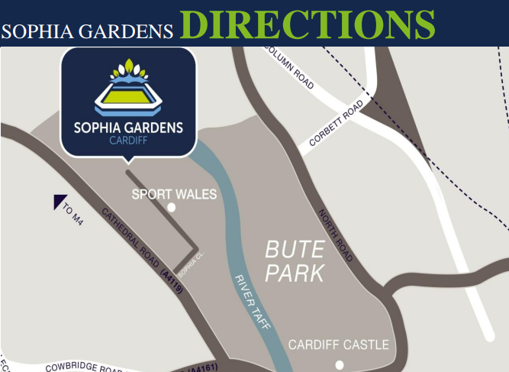
Our Address
Glamorgan County Cricket Club,
Sophia Gardens
Cardiff
CF11 9XR
You really can't miss us, but if you do, call 02920 409 380, email info@glamorgancricket.co.uk or tweet @glamcricket
Getting To Sophia Gardens Stadium
On Foot
The most popular and pleasant means of reaching Sophia Gardens from Cardiff Central Station is on foot. The final part of the 15 minute leisurely stroll takes you along the banks of the River Taff through Bute Park and the grounds of Cardiff Castle.
Cycling
A popular way to travel to the Stadium is by bicycle and we are in the ideal location to do so i.e. via the Taff Trail which runs from Cardiff Bay to Brecon. The Stadium has more than 30 cycle parking spaces located underneath the Altodigital stand.
Use www.traveline-cymru.info for help with planning your route, or use the walking and cycling map (https://www.cardiff.gov.uk/ENG/resident/Parking-roads-and-travel/Walking-and-cycling/Documents/Cardiff%202018_WEB.pdf).
You can rent an OVO bike by visiting one of the OVO Bike and e-bike stations in Cardiff. The nearest station is on Sophia Close. Visit the website to view locations and find out how to rent at https://www.nextbike.co.uk/en/cardiff/
By Train
For details of the regular inter-city and high-speed trains that run between Cardiff and all major towns and cities including London, Bristol, Birmingham and Swansea, please visit: www.nationalrail.co.uk
By Coach
Regular high-speed coaches leave from Cardiff from most major locations in the UK. Please visit www.nationalexpress.com for further information.
By Bus
Cardiff Bus services run regularly between Cardiff Central Station and Cathedral Road (adjacent to Sophia Gardens)
Routes going via Cathedral Road include:
- Number 25 Circular Service to Llandaff North and North Road
- Number 62 Service to Llandaff, Danescourt, Pentrebane, Fair Water & Canton.
- Number 63 service Ffordd Berllan, Central Station, Radyr to Llandaff.
If you are planning to travel by bus please use www.travellinecymru.info for more information.
By Road
- From the East - Exit the M4 at Junction 29 and follow the A48M towards Llandaff. Join Cardiff Road. Sophia Gardens is situated off Sophia Close which is on Cathedral Road.
- From the West - Exit the M4 at Juntion 33. Follow the A4232 for 6.2 miles and exit on the slip road onto Leckwith Road. Follow the A4161 and then turn left onto Cathedral Road (A4119). Turn right onto Sophia Close where Sophia Gardens is situated.
- Satellite Navigation Users: Enter postcode as CF11 9XR providing parking has been pre-arranged.

