we are recruiting

join our board

Disability Wales
Sbarc|Spark
Cardiff
CF24 4HQ
T: 029 2088 7325
F: 029 2088 8702
E: info@disabilitywales.org

www.disabilitywales.org

Disability Wales receives funding from Welsh Government

Charity Number: 517391
Company Number: 1998621

A twitter.com/DisabilityWales
B facebook.com/Disability Wales F YouTube.com/Disability Wales O flicker.com/Disability Wales

get
in touch

Recruitment Opportunities for Board Members 2

foreword

Thank you for your interest in joining the Board of Disability Wales (DW) as either an elected or appointed Director. This pack tells you more about the role of the Board and being a Director. It also gives information on how to apply as an appointed Director.

DW is the national Disabled People’s Organisation, working co-productively with our members to tackle a wide range of disabling barriers in society. We want
to see disabled people enjoying the same rights as others including access to housing and transport, opportunities in education and employment and the ability to fully participate in social and cultural activities.
DW is an innovator and since our establishment in 1972, has achieved many ‘firsts’, including:
- Access Building Awards Scheme (1979-91) and the first ever Access Design Guidance Notes (1978)
- Development of new national and local disability organisations in the fields of sports, the arts, young people and access (1980s – )
- First programme in Wales to train disabled people to become Disability Equality Trainers (1992)
- High profile campaigns on Access to the High Street, Disability Hate Crime, Independent Living and Welfare Reform (2008- )
- Actively contributed to development of Social Care Charging Measure 2011
- Successfully campaigned for the introduction of Welsh Government’s Framework for Action on Independent Living (2013)
- Active engagement in development of the Social Services and Wellbeing (Wales) Act (2014)
- A partner in the world’s first research programme led by disabled people (Disability Research in Independent Living and Learning (DRILL) (2015 to date)
- Establishment of the first user-led co-operative in the UK run by and for Direct Payments recipients (2017)

- Representation of Disabled People from Wales at the United Nations in Geneva at the first examination of the UK Government regarding the UN Convention on the Rights of Disabled People (2017)
- Distributing Covid-19 Emergency Grants to 9 Disabled People’s Organisations across Wales on behalf of the National Emergencies Trust and Welsh Government (2020)
- Successfully lobbying Welsh Government for and receiving funding to set up the Access to Elected Office Fund in Wales to assist disabled people standing for elected office in the Senedd and local government elections (2021)

“Being a Director of Disability Wales enables me and my fellow board members, all of whom are disabled people, in upholding the rights and equality of disabled people in Wales”. (serving Board Member)

Our members are at the heart of the organisation and we provide the following services and opportunities to support their growth:
- News and information via our website, resource packs and toolkits, e-news and social media platforms
- An annual programme of regional events, conferences and workshops for members and stakeholders on topical issues
- Training and development opportunities to build capacity

- Opportunities to influence Welsh Government, UK Government and public bodies through campaigns, consultations and research initiatives
- A training and consultancy service aimed at promoting good practice among employers, service providers and policy makers

We are looking for a wide range of skills and experiences on the Board and as an organisation we want to reflect the whole community of disabled people in Wales.

“Being a relatively new Director for Disability Wales has been a challenge and a pleasure. We get to shape policy and make decisions about the future of this leading organisation in the disability arena. Working alongside people with more experience makes the role easier. If you have an interest in disability in Wales and how it impacts your life then I would encourage you to find out more”. (serving Board Member)
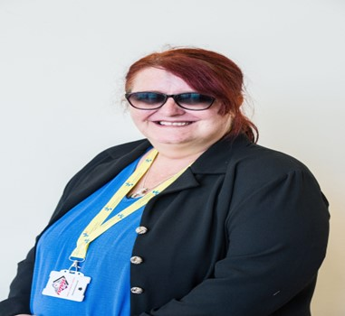
As a Disabled People’s Organisation we aim to demonstrate good practice in governance. We strive to provide a supportive and fully inclusive environment which enables Directors to flourish as well as maximise their talents through a range of opportunities.
We look forward to receiving your application or nomination form.

Willow Holloway
Chairperson

who we are

Disability Wales (DW) is the national association of Disabled People’s Organisations (DPOs) striving to achieve rights, equality and independent living of disabled people in Wales.

DW promotes the adoption and implementation of the Social Model of Disability, which identifies that it is environmental, organisational, and attitudinal barriers that disable people and prevent their full participation in society not their medical conditions or impairments.
DW is an independent, not for profit organisation established in 1972 that receives grant funding from Welsh Government’s Equality Division.
DW is managed by a voluntary Board of Directors drawn from disabled people active in local and national disability organisations across Wales. Most of
our staff are disabled people with many years’ experience working in both a professional and voluntary capacity for various disability organisations in Wales and beyond.
DW’s unique role within Wales is being an umbrella organisation that champions the rights and equality of all disabled people regardless of physical or sensory impairment, learning difficulty or mental health condition. We recognise that many disabled people will have other identities which may result in intersectional discrimination.
DW engages member campaigns, consultations, research and policy development in order to influence the development of government policy and practice in respect of disabled people. We provide information, training and support to members across Wales through social media as well as conferences, seminars and events. DW identifies a strong and thriving network of disabled people’s organisations as vital to achieving both effective and innovative national policy and local service delivery.

our aims

Mission

Our core role is to represent the views and priorities of members to government with the aim of informing and influencing policy.

- Strategic Aim 1: To influence policy and decision makers at all levels, through acting as an effective advocate for the views, priorities and interests of our members
- Strategic Aim 2: To develop and support the work of organisations managed and controlled by disabled people
- Strategic Aim 3: To lead and develop an effective, sustainable organisation and ensure sound and robust governance

Values
- The Social Model of Disability
- Equality, Diversity and Human Rights
- An Inclusive Society
- Self-determination
- Beacon of best practice
- Committed to achieving equality.

Recruitment Opportunities for Board Members 7

social model of disability

Disability Wales promotes the adoption and implementation of
the Social Model of Disability throughout our work and all staff are expected to develop in-depth knowledge and understanding of how to apply it within their particular field operation.
The Social Model of Disability was developed by disabled people and makes the important difference between ‘impairment’ and ‘disability’, defined as follows:
- Impairment: An injury, illness, or congenital condition that causes or is likely to cause a long-term effect on physical appearance and/or limitation of function within the individual that differs from the commonplace.
- Disability: The loss or limitation of opportunities to take part in society on an equal level with others due to social and environmental barriers.

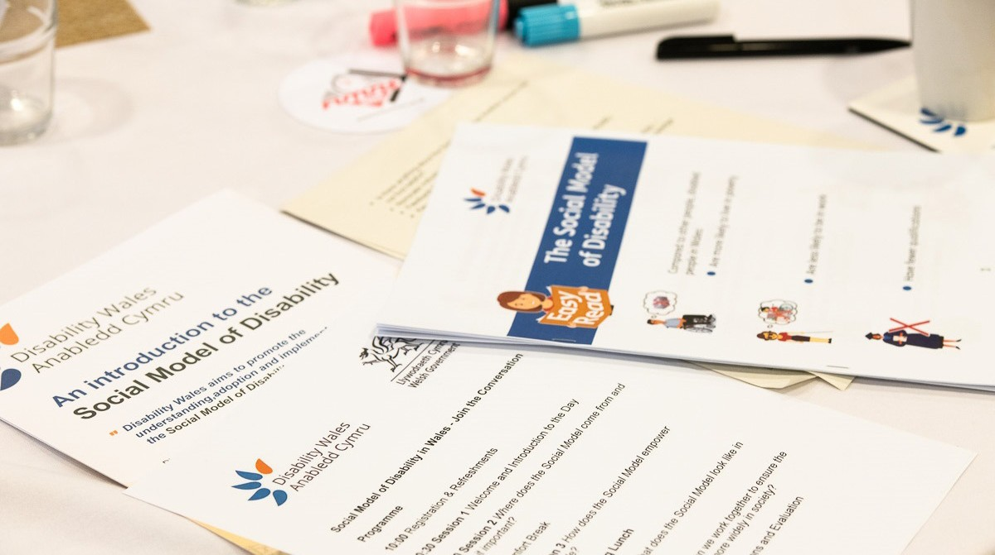

Disability is shown as being caused by ‘barriers’ or elements of social organisation which take no or little account of people who have impairments. Society is seen to disable people who have impairments because the way it has been set up prevents us from taking part in everyday life. It follows that
if disabled people are to be able to join in mainstream society, then the way society is organised must be changed.
Removing the barriers which exclude (and disable) people who have impairments can bring about this change. There are three main types of barrier facing disabled people:
- Environmental barriers: lack of access in and around the built environment including transport systems
- Attitudinal barriers: where disabled people are regarded as inferior, helpless, weak and vulnerable
- Institutional barriers: policies and procedures that prevent the full participation of disabled people within education, the work place and the wider community
Disability Wales is campaigning and working to remove all disabling barriers in Wales whether environmental, attitudinal or institutional.
For further information on the Social Model and Medical Model of Disability, please visit www.disabilitywales.org

how do I become a board member
There are two routes to membership of DW’s Board of Directors:

- Nomination as the named representative of a full member Disabled People’s Organisation and elected at the AGM, following a ballot of members if required
- Appointed by the Board of Directors through an open and competitive application process
Whether elected or appointed to the Board, all Directors have an equal say in decision making regarding the strategic direction and policy development of DW.

Elected Board Members
There are a maximum of fifteen places for elected Directors. Nomination papers including candidate information and acceptance forms are circulated to all full member DPOs at least 12 weeks prior to the AGM.
Only nominated members of full member DPOs may be elected to the Board.

Appointed Board Members
There are a maximum of five places for appointed Directors. Appointed Directors will be appointed to ensure access to knowledge, skills and expertise not otherwise available to the Board as well as ensuring that the Board reflects the diversity among the whole community of disabled people.
Recruitment of appointed Directors includes submitting a written application and if shortlisted a panel interview. All applications and interviews are assessed against criteria outlined in the Director’s role description and person specification which is supplied in the application pack.
Additionally, applicants may also need to demonstrate knowledge, skills and/or expertise in specific areas which the Board is seeking to acquire.

board member opportunities

Recruitment Opportunities for Board Members 11

Board of Directors – Role description

Role title | Director / Trustee
Accountable to | Chairperson and Board of Directors
Term of Office | Elected Directors – Three years (subject to any requirement re annual rotation of Board members) Appointed Directors – up to three years
Role purpose | Together with fellow Directors/Trustees to be responsible for developing DW’s policy and work; managing the organisation including its money and people; and serving the best interests of DW at all times
Commitment | To regularly attend Board meetings and participate in discussion and decision making; to read papers in advance of the meetings; to attend and participate in Board Induction and other Training as required; to participate in Annual Appraisal and personal development interviews with the Chairperson

Main Responsibilities

Developing DW’s Policy and Work
- Develop and implement Disability Wales policy
- Give strategic direction to the organisation including its staff; defining goals, setting targets and evaluating performance
- Promote and safeguard the good name and values of the organisation.

Managing People and Money
- ensure the effective and efficient administration of the organisation
- ensure the financial stability of Disability Wales
- manage Disability Wales property and resources
- ensure proper investment of Disability Wales funds
- employ and ensure effective management of Disability Wales staff in line with legal requirements

Legal responsibilities
- ensure that Disability Wales complies with its governing documents, charity law, company law and any other relevant legislation or regulations
- ensure that Disability Wales pursues its charitable objects
- ensure that Disability Wales applies its resources exclusively in pursuit of its objects

Promoting Disability Wales
- Promoting DW’s aims, objectives and values amongst members and stakeholders
- Supporting the Chief Executive in representing DW at external events and meetings
- Promoting and encouraging good relations between DW and its members and stakeholders

Board Members must act in the interests of Disability Wales membership as a whole. They are not appointed to represent any single organisation or sector. Directors are obliged by Charity Law, Company Law and all other relevant legislation and regulations to put the interests of Disability Wales first in all Board decisions and to declare any conflict of interest.

Person Specification for all Directors
Essential Criteria
All Directors of Disability Wales must be disabled people

Directors should know about:
- Disability equality issues
- the Disabled Peoples’ Movement in Wales
- the Social, political and economic issues of Wales and how these affect disabled people

Directors should value, promote and practice:
- Commitment to Disability Wales
- the Social Model of Disability
- principles of empowerment of disabled people
- the principle that disabled people should control their own organisations
- The role of non-disabled people as allies in the organisation and elsewhere
- The expertise and experience of disabled people
- Equality, Diversity and Human Rights
- Strategic vision for Disability Wales
- Impartiality, fairness and confidentiality (see Appendix 1: the Nolan Principles)

Directors should have experience of:
- Being a Trustee/ Director of a local or national organisation
- The Public, Business or Voluntary Sector
- Thinking and working strategically
- Policy development

Desirable Criteria
And one or more of the following:

- Financial Management, Business Development and/or Income Generation
- Human Resource management
- Lobbying and campaigning
- Media and Marketing
- Public Sector Procurement
- Environmental issues and sustainable development
- Welsh Language and Culture
- Public or Commercial Law
- Lived experience of or demonstrable active allyship with another protected characteristic

What support can I expect from DW to carry out my duties?
- Induction and development – Directors are required to attend the annual induction/refresher programme covering the following issues:

  - the roles and responsibilities of Charity Trustees and Company Directors
  - disability equality issues – the Social Model of Disability and related concepts
  - the Disabled People’s Movement in Wales
  - DW's aims, objectives and procedures
  - Disability Wales and its members
  - Equality, Diversity and Human Rights
  - Sustainability

Where appropriate, Directors will have the opportunity to attend development seminars on issues including:
  - finance and funding
  - employment issues and team management
  - media and PR issues
  - strategic and project planning
  - committee skills

Information
All Directors will be provided with a comprehensive Directors’ Information File in an appropriate format.

Personal Development Interviews
All Directors are required to participate in an annual one-to-one meeting with the Chairperson to discuss their attendance and progress over the last year and identify any further support or learning needs they may require.

Payment of authorised expenses
As part of DW's Equal Opportunities policy it reimburses out of pocket expenses as per agreed Expenses Policy.

Code of conduct
To guide you in your duties DW has a Code of Conduct for Directors, which all Directors must sign on appointment.

Access requirements
DW strives to ensure that all its activities are fully accessible and aims to accommodate all individual access requirements including with physical access, transport, communication, information, dietary needs and personal assistance.

Equality and Diversity
DW strives to ensure that its activities are open to all within the community of disabled people and aims to accommodate requirements including childcare and religious observance

Time commitment
  - 6 Board meetings a year, usually from 10.30 am – 1.00 pm
  - Occasional Task and Finish Groups/Recruitment Panels (3 – 4 meetings)
  - Time necessary to read and work on Board/Committee papers
  - Training and induction - approximately 2 days per annum
  - Strategic Reviews (1 day per year)
  - 1 x AGM and Annual Conference per year and conference, when applicable
Total: approximately 12 days per annum
DW Board meetings are currently being held on a hybrid basis, using the online facilities at Spark in Cardiff.

Legal Requirements
Please note that under company law, an individual may not be appointed or elected as a Director if they:

  - have been disqualified from acting as a company director
  - are an undischarged bankrupt
  - are under the age of 16
If you have any concerns regarding your eligibility to become a Director, please contact the Chief Executive at Disability Wales in confidence to discuss it further

Further Information
Where can I find out more about Disability Wales?

Website: www.disabilitywales.org
By emailing us info@disabilitywales.org
Or telephoning the DW Office 029 2088 7325

If you wish we can put you in contact with a Board Director for an informal discussion about the roles and responsibilities of being a Board Member.

Appendix 1
THE SEVEN PRINCIPLES OF PUBLIC LIFE
“The Nolan Principles”

Selflessness
Holders of public office should act solely in terms of the public interest. They should not do so in order to gain financial or other material benefits for themselves, their family, or their friends.

Integrity
Holders of public office should not place themselves under any financial or other obligation to outside individuals or organisations that might seek to influence them in the performance of their official duties.

Objectivity
In carrying out public business, including making public appointments, awarding contracts, or recommending individuals for rewards and benefits, holders of public office should make choices on merit.

Accountability
Holders of public office are accountable for their decisions and actions to the public and must submit themselves to whatever scrutiny is appropriate to their office.

Openness
Holders of public office should be as open as possible about all the decisions and actions that they take. They should give reasons for their decisions and restrict information only when the wider public interest clearly demands.

Honesty
Holders of public office have a duty to declare any private interests relating to their public duties and to take steps to resolve any conflicts arising in a way that protects the public interest.

Leadership
Holders of public office should promote and support these principles by leadership and example.

application information

Completing the Application Form for Appointed Directors
You may either type or write in black pen to complete your application form. We strongly recommend that you:
- Complete all sections of the application form
- Study the Role Description and Person Specification carefully
- Include relevant examples to illustrate your knowledge, skills, experience and values
- State your personal contribution to work achieved

Personal Details and Availability
Fill out this section accordingly making sure all contact details are correct.

Education and Qualifications
Ensure to include all relevant qualifications and level achieved.

Training
Please give details of any training courses you have completed.

Professional Bodies
Please state whether you are a member of any professional bodies, indicating your level of membership and qualification.

Employment and Volunteering History
DW understands that not all potential applicants will have obtained paid employment, so volunteering and personal experience are equally valued. If applicable, please start with your current or most recent employer and give a brief description of your main responsibilities of that role. These descriptions do not have to be very long as you will have an opportunity to expand on certain aspects in the Statement of Suitability section. Please provide details of any previous and/or current experience of voluntary work and/or roles in public life.

Recruitment Opportunities for Board Members 19

Statement of Suitability
Outline any relevant skills, experience and training appropriate to this post.

As we shortlist against the criteria you should relate your application to the requirements set out in the person specification (providing examples). Please address each section in sufficient detail and avoid leaving any blank spaces. If you do not complete all of the sections, this may impact your likelihood of being shortlisted.
Give clear, short paragraphs that show how your experiences meet the criteria

Referees
Your referees should be your current or previous line manager, academic tutor or a volunteer manager if applicable. Do not give details of family, friends or colleagues.
We reserve the right to request to approach any previous employer if deemed necessary.
Referees will only be contacted after an offer has been made. We will confirm this with you before we approach your referees. If there is a problem with this then please contact us.

Equal Opportunities Form
Please be assured that this is not part of the application process and will be removed prior to the shortlisting process.
However, the data we obtain from these forms is analysed due to our commitment to equal opportunities and the information will help us to guide our recruitment strategies.

Recruitment Opportunities for Board Members 20

