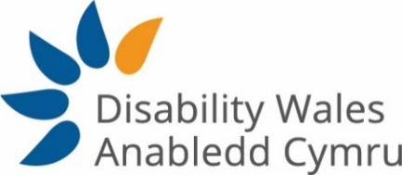
_____________________________________________
Job Description

Job title: Civic Participation Administrator

Salary: £17,842 (pro rata £13,468)

Hours: 28 hours per week

Place of work: Caerphilly (remote home working currently due to Covid-19)

Responsible to: Civic Participation Officer

Key relationships: DW Staff Team, DW Board of Directors, DW Members, Stakeholders

Contract: Fixed Term Contract until 30th June 2022
_________________________________________________________

An outline profile of the post:

- To assist the Civic Participation Officer by providing efficient administrative support to the Access to Elected Office Fund Wales, which provides financial assistance to disabled people standing for election in the Welsh Local Government Election 2022.

Job Responsibilities:

- Provide administrative support to ensure the efficient administration of the Access to Elected Office Fund Wales.
- Provide potential applicants with information about the scheme to enable them to make an application,
- Support applicants to the scheme to complete the application form providing necessary information for Decision Making Panel to arrive at a decision.
- Review applications to ensure the Decision Panel has sufficient information to arrive at a decision.
- Assist the Civic Participation Officer in the preparation of documentation for Decision Panel meetings. Ensuring their decision are accurately recorded.
- Assist with the management of online promotional events, information sessions and Decision Panels.
- Maintain the confidentiality of the personal data of applicants to the Fund.
- Liaise with successful applicants to procure the support they have been awarded.
- Liaise with the Finance and Administration Officer in ensuring appropriate administration and support to applicants and recipients of the fund.

Key Tasks

- Send out information and application forms in the accessible format required by potential applicants.
- Assist the Civic Participation Officer and Finance and Admin Officer in costing and procuring the approved assistance, as required.
- Carry out checks on requests for payment to ensure they comply with the approved award.
- Comply with appropriate financial due diligence, data protection procedures and ensure cyber security standards are followed in line with GDPR and Welsh Government requirements.
- Provide administrative support to the Decision Panel; and accurately record the Panel’s decisions.
- Arrange support on behalf of disabled candidates as required.
- Assist the Civic Participation Officer to collect case study evidence about the effectiveness of the scheme from beneficiaries.
- Collate monitoring information for reporting purposes.
- Provide additional administrative support for the organisation when needed.
- To undertake any other duties as required which are in keeping with the aims of the post.
- Assist in the carrying out of monitoring and evaluation activity, ensuring consistency of data and good tracking of beneficiaries.

