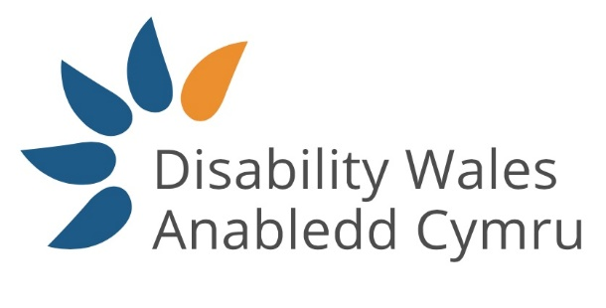
Easy Read

What do you think about the UNCRDP and rights for disabled people in Wales?
Survey
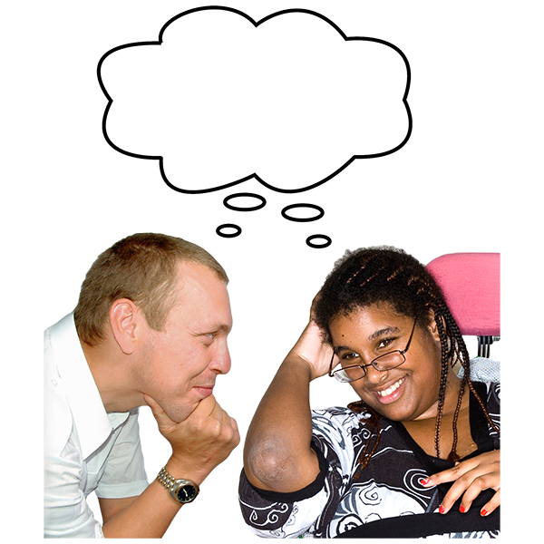
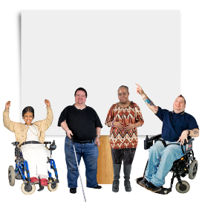

This survey was written by Disability Wales. It is an easy read version of ‘.

November 2021

About this survey
This is an easy read survey. But you may still need support to read it and answer the questions. Ask someone you know to help you.
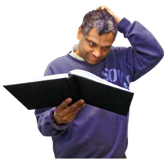

Words in bold blue writing may be hard to understand.

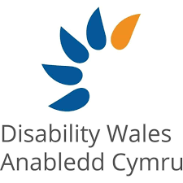
Where the document says we, this means Disability Wales. For more information contact:
Website:
E-mail:
Phone:

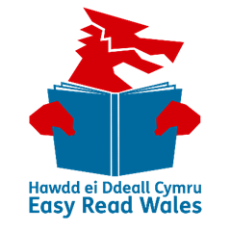
This survey was made into easy read by Easy Read Wales using Photosymbols. To tell us what you think about this easy read version, click here.

Introduction
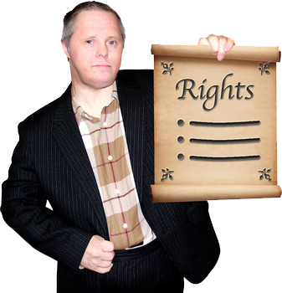
We are Disability Wales. We are looking into the UNCRDP. And how it makes a difference to the rights of disabled people in Wales.
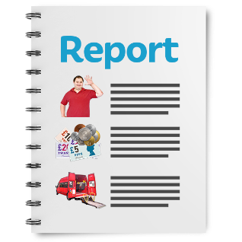
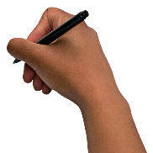
UNCRDP stands for United Nations Convention on the Rights of Disabled People. Countries sign up to this agreement to protect and promote the rights of disabled people.
We are writing a report about the UNCRDP and rights for disabled people in Wales. Please help us by answering these questions about your rights in Wales.
Please e-mail your answers back to us by 22 November 2021. If you have any questions, or need any help with this survey, please contact:
Megan Thomas
E-mail: megan.thomas@disabilitywales.org
Phone: 029 2088 7325

Questions about you
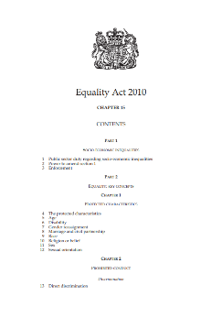
The Equality Act 2010 says you are disabled if you have a physical or mental impairment that:
- makes everyday activities difficult,
- over a long period of time.

Question 1. Do you see yourself as disabled?
Yes ☐ No ☐
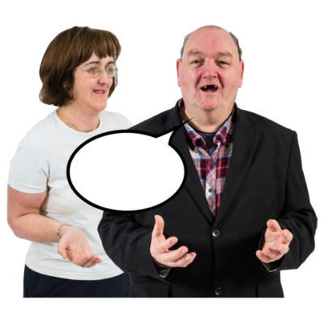

Question 2. Are you answering this survey on behalf of a disabled person or organisation?
Yes ☐ No ☐
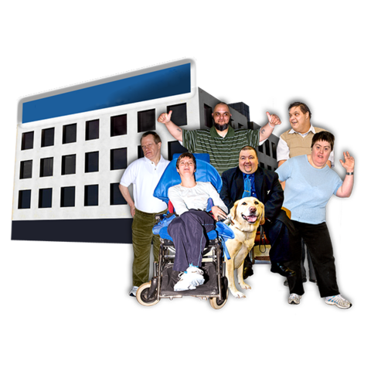

Question 3. If you are answering this survey on behalf of an organisation, please tell us the name of your organisation:

Questions about the UNCRDP
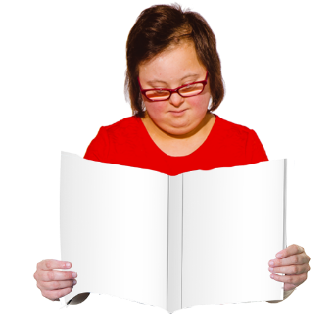
Question 4
Please read the following information and then answer question 4 on page 8.
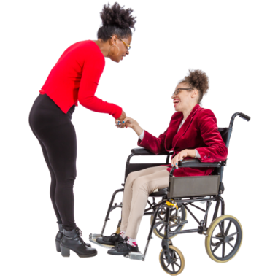
Part 3 of the UNCRDP says disabled people should:
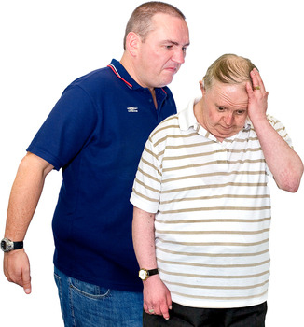
- be treated with respect. They should be free to make their own choices and live independently.
- not be discriminated against.

Discriminate means being treated badly or unfairly because of things like your age, disability or race.
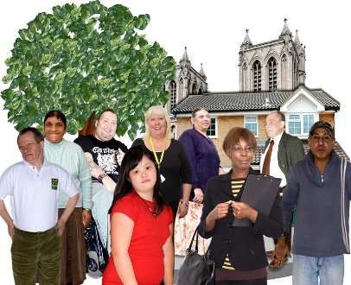
- be included in society and accepted
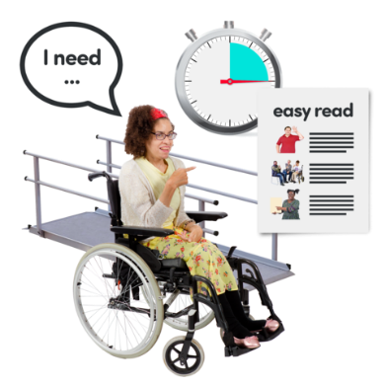
- have equal chances in life. And men and women should be treated equally
- be able to find, get to and use things like buildings, services and information
Part 4 of the UNCRDP says that countries that sign up to the UNCRDP should:
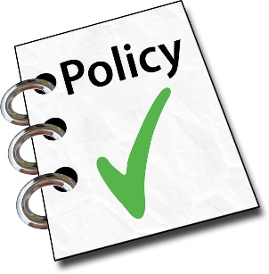
- have the right laws, policies and plans in place to support the rights of disabled people
- do everything they can to put an end to things that discriminate against disabled people. Including discrimination by any person, organisation or business.
- Think about disability rights when writing every policy and plan
- Make sure the government and all local authorities follow the UNCRDP.
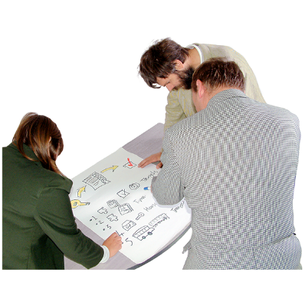
- Make sure buildings, services and communities are designed in a way that make them easy for everyone to use.
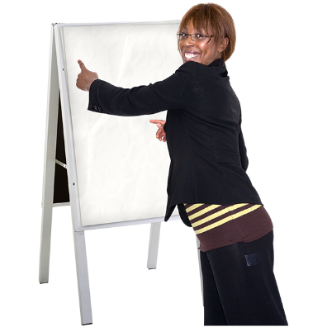
- Give disabled people information in a way they can understand
- Make sure people who work with disabled people have disability rights training
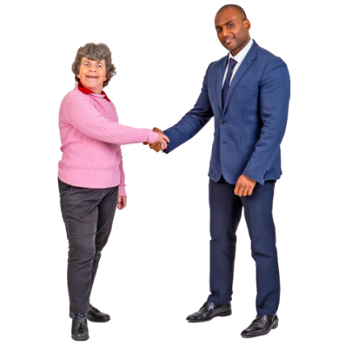
- Use all available money, staff, time and other resources to support disabled people to make full use of all their rights
- Work with disabled people through disabled people’s organisations when writing and designing new laws and policies.

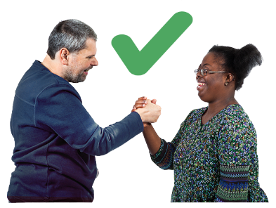
Part 5 of the UNCRDP says that the following ideas are important for equality and for ending discrimination:
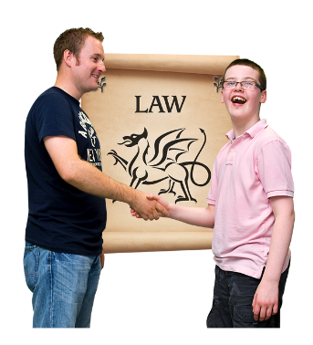
- Everyone is equal by law. And everyone has the right to equal protection from and benefit of the law.
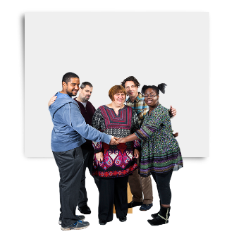
- A promise that people will not face discrimination because of a disability. And a promise to disabled people for equal protection by law from discrimination.
- We should all be doing things to make sure disabled people are provided for.

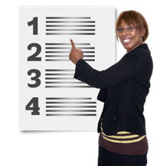
Question 4. Do you think Welsh Government and UK Government follows all of the ideas from part 3, 4 and 5 of the UNCRDP?
Yes ☐ No ☐ Not sure ☐

Is there anything more you would like to say about this? Please use the box below:

Question 5
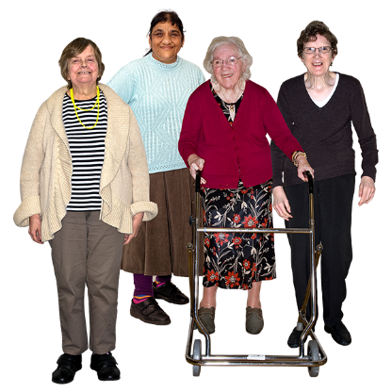
Part 6 of the UNCRDP focuses on disabled women. It says that disabled women experience discrimination in lots of ways. And that we must pay extra attention to making sure disabled women have equal rights.

Question - Do you think enough work is being done on the rights of women, especially disabled women, in Wales? Please use the box below:

Question 6
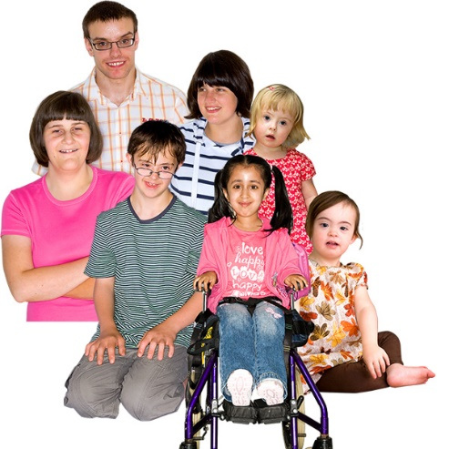
Part 7 of the UNCRDP focuses on disabled children. It says that:
- We should do everything we can to make sure disabled children get their full human rights and freedoms.
- The health and wellbeing of disabled children is the most important thing to think about.
- Disabled children have an equal right to give their thoughts and ideas.

Question - Do you think these things are happening in Wales for disabled children? Please use the box below:

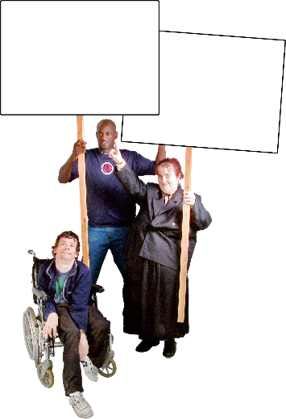
Question 7
Part 8 of the UNCRDP is about raising awareness. It says that:
- We must focus on raising awareness about disabled people. And fight labels and unfair ideas about disabled people.
- We must work to make sure the public know more about disabled people. And work to make sure we properly represent disabled people on things like TV.
Question - Do you think these things are happening in Wales for disabled children? Please write your answer in the box below:

Question 8
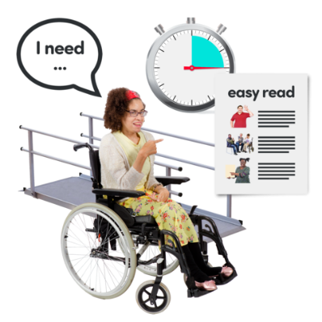
Part 9 of the UNCRDP focuses on accessibility.

Accessibility is about how easy things are for everyone to find and use.

Part 9 says disabled people should be able to easily use things like:
- Transport
- Information
- Services
- Public buildings and spaces.

Question - How accessible do you think these things are for disabled people in Wales? Please write your answer in the box below:

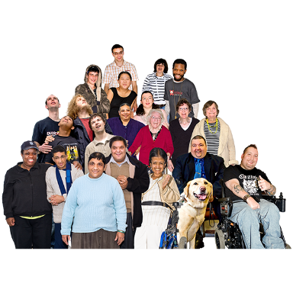
Question 9
Part 10 of the UNCRDP says that all human beings have the right to life. And that everything possible must be done to make sure disabled people’s right to life is respected.

Question - Do you think disabled people’s right to life is respected in Wales? Please write your answer in the box below:

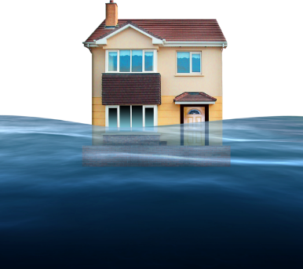
Question 10
Part 11 of the UNCRDP is about making sure everything possible is done to protect disabled people during risky situations and emergencies. For example:
- Natural disasters, like floods and earthquakes.
- War
- Health related epidemics – like coronavirus
- Big accidents in places like factories

Question – do you think we are doing our duty to support disabled people around the world in these types of situations? Please write your answer in the box below:

Question 11
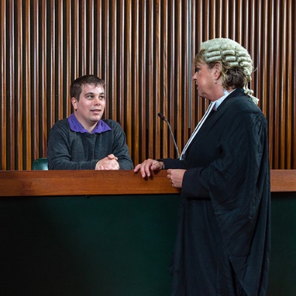
Part 12 of the UNCRDP says that people are equal before the law. It says that:
- Disabled people have the right to be seen as a person before the law. They have the same rights as others to use the law.
- If someone is not able to make their own decisions, all possible safety measures should be in place to protect them from abuse.
- Disabled people have the same right as any other person to own their own property and control their own money.
Question – Thinking about the above 3 points, do you think disabled people are seen as equal before the law in Wales? Please write your answer in the box below:

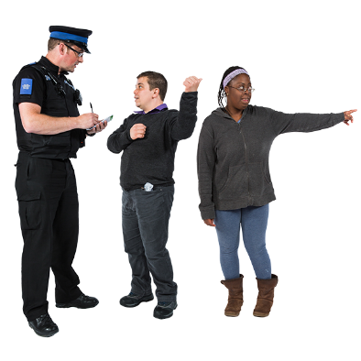
Question 12
Part 13 of the UNCRDP focuses on a person’s right to justice.

Justice means using the law to fairly judge someone’s actions and make sure people are treated fairly.
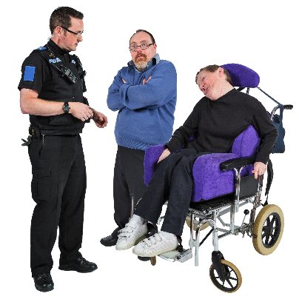
Part 13 says disabled people should have support to use the law if needed. And staff working in law, like police, prison officers, solicitors, and judges should have the right training to support disabled people.

Question – do you think disabled people have equal access to justice in Wales and the UK. Please write your answer in the box below:

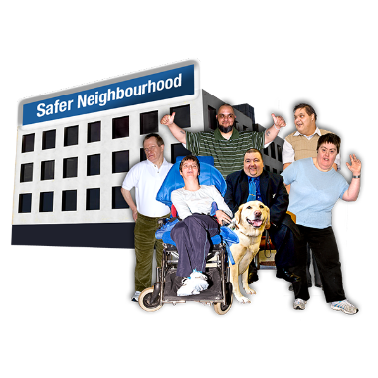
Question 13
Part 14 of the UNCRDP is about disabled people’s right to freedom and safety.
If a disabled person is robbed of their freedom for any reason, they have the right to protection by the law.
Question – Do you think disabled people in Wales are fully given the right to freedom and safety? Please write your answer in the box below:

Question 14
Part 15 of the UNCRDP is about freedom from torture and cruel treatment or punishment.

Torture is when someone hurts you very badly and makes you suffer, as a punishment. Or to force you to do or say something.

Part 15 says no one should be treated this way. Government should do everything it can to make sure no one is treated this way.
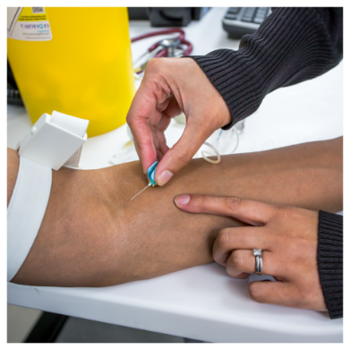
It also says no one should be forced into tests or experiments for science or medicine, without giving their consent. And without the proper safety measures in place.

Question – Do you think disabled people in Wales and the UK are free from torture and cruel treatment? Please write your answer in the box below:

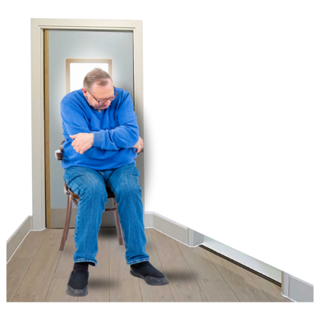
Question 15
Part 16 of the UNCRDP is about your right to be free from exploitation, violence, and abuse.

Exploitation is when someone treats you very unfairly or uses you to benefit from you in some way.

Part 16 says everything possible must be done to protect disabled people from these things.
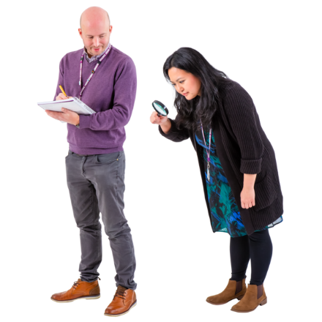
Services that support disabled people who have experienced these things should be checked often. And should put the needs of the person first.
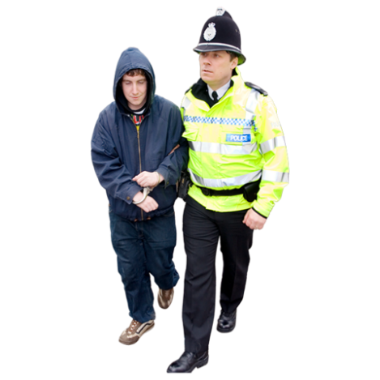

Abuse, violence or exploitation of a disabled person should be investigated. And the people responsible should have to answer to the law.

Question – Do you think disabled people in Wales and the UK are properly protected from these things? Please write your answer in the box below:

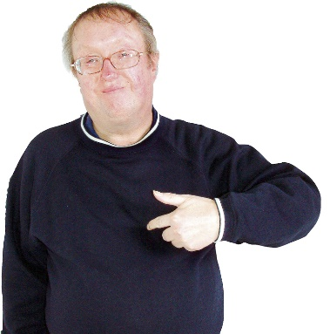
Question 16
Part 17 of the UNCRDP says disabled people have the same right as everyone else to have control over this own body and mind.

Question – Do you think disabled people in Wales and the UK have the full right to make decisions about their own bodies and minds? Please write your answer in the box below:

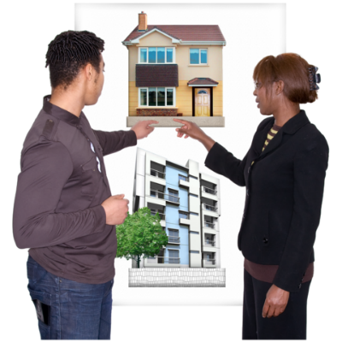
Question 17
Part 18 of the UNCRDP is about the right of disabled people to live where they want to. And to feel they belong to a nation.
Part 18 says disabled children have the right, from birth to:
- a name
- belong to a nation
- and if possible to know and be cared for by their parents.

Question – Do you think disabled people in Wales and the UK have this right? Please write your answer in the box below:

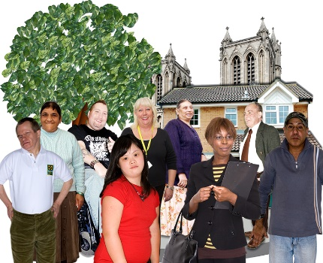
Question 18
Part 19 of the UNCRDP is about independent living. And being a part of your community,
Part 19 says disabled people have the right to live in and be involved in their community. And they have the right to choose where they live and have the support they need to live there.

Question – Do you think disabled people are given the right to live independently, and be included in their community in Wales and the UK? Please write your answer in the box below:

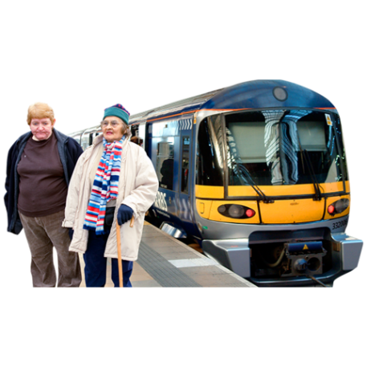
Question 19
Part 20 of the UNCRDP is about the right to be able to get around. Whether by walking, using public transport or a car. Disabled people should be supported to get around in the way they choose. For example, transport staff should have training, and information should be easy to use.
Question – Do you think disabled people in Wales are supported to get around in the way they choose? Please write your answer in the box below:

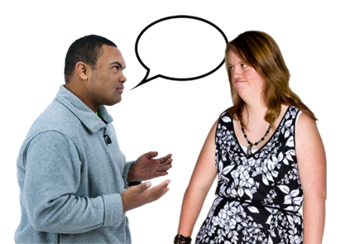
Question 20
Part 21 of the UNCRDP focuses on disabled people’s right to give their opinions. And find and share information and ideas.
It includes providing accessible information and promoting the use of sign language.
Question – Do you think disabled people have their full right to give their opinions, and access information in Wales? Please write your answer in the box below:

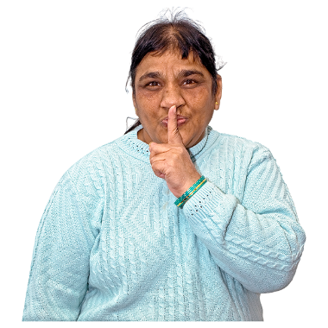
Question 21
Part 22 of the UNCRDP says disabled people have the right to privacy. Government should protect their information the same as everyone else’s. And they should have the same protection under the law.
Question – Is disabled people’s privacy respected in Wales and the UK? Please write your answer in the box below:

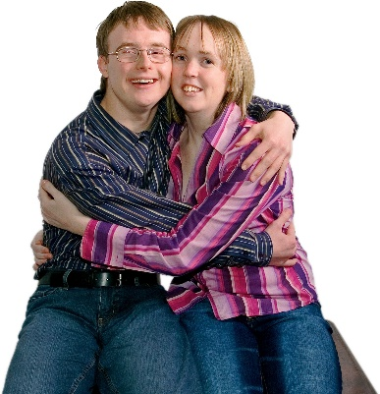
Question 22
Part 23 of the UNCRDP says disabled people have the same rights as everyone else to marriage, family, parenthood and relationships.
Question – Do you think disabled people’s right to a home and family life is respected in Wales and the UK? Please write your answer in the box below:

Question 23
Part 24 of the UNCRDP says disabled people have the right to education. This includes:
- making sure disabled people have the support they need to get education
- thinking about the communication needs of disabled people.
Question – Do you think disabled people are given their full right to education in Wales? Please write your answer in the box below:

Question 24
Part 25 of the UNCRDP says disabled people have the right to good health and good health services.
Question – Do you think disabled people are given their full right to health in Wales? Please write your answer in the box below:

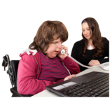
Question 25
Part 26 of the UNCRDP says disabled people have the right to be supported by health, jobs, education and social services.
Question – Do you think disabled people have access to these services in Wales? Please write your answer in the box below:

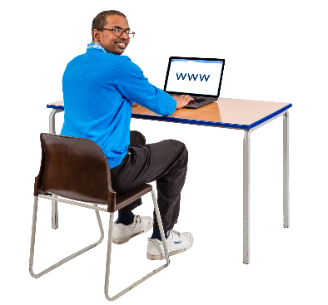
Question 26
Part 27 of the UNCRDP says disabled people have the right to work.
Question – Do you think disabled people’s right to work is respected in Wales? Please write your answer in the box below:

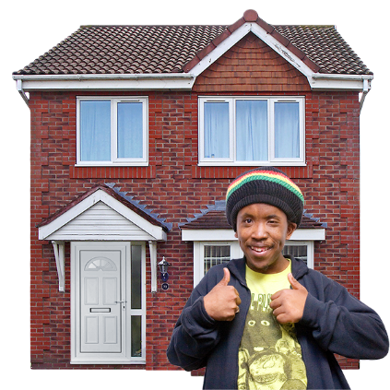
Question 27
Part 28 of the UNCRDP says disabled people have the right to a good level of living, for example, good homes, food and clothes. This includes the right to support to achieve a good level of level.
Question – Do you think disabled people’s right to a good level of living is respected in Wales? Please write your answer in the box below:

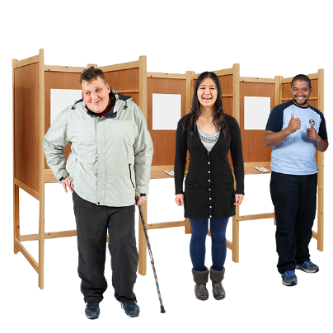
Question 28
Part 29 of the UNCRDP says disabled people have the right vote and be involved in politics. And public life.
Question – Do you think disabled people’s right to be involved in politics and public life is respected in Wales? Please write your answer in the box below:

Question 29
Part 30 of the UNCRDP says disabled people have the right to take part in culture, leisure and sport.
The government should make sure disabled people have an equal chance to take part in these types of activities.
Question – Do you think there is enough support for disabled people to take part in culture, leisure, and sport? Please write your answer in the box below:

Thank you for your answers.

