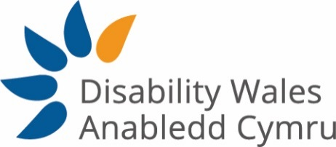

Person Specification – Policy and Research Officer (EU Transition)
The post holder must be a disabled person
 | Essential | Desirable
Qualifications

Degree or equivalent experience | E
Experience

Experience of policy development in a complex environment | E
Experience of writing policy documents of varying length and for a variety of audiences | E
Experience of lobbying and campaigning at government level and an understanding of political processes and how to influence | E
Relevant experience in working collaboratively with disabled people and their organisations | E
Experience of facilitating a diverse range of stakeholders contributing to the development of good policy and practice | E
Experience of using community development/capacity building techniques | E
Experience in undertaking and delivering research studies | E
Experience of producing evaluation reports | E
Previous experience of working in the third sector |  | D
Knowledge

Understanding of the political and policy making process in Wales and levers for influencing change | E
Knowledge of the impact of Brexit particulary on disabled people; and of the Trade and Co-operation Agreement | E
An understanding of the strategic context (EU and government policy and practice) and political institutions | E
Understanding of co-production as a method of joint working in relation to policy and practice | E
Drafting funding bids and tenders |  | D
Knowledge of working within the Third Sector and the associated policies and procedures |  | D
An understanding of the strategic context (EU and government policy and practice) and political institutions

Skills

Ability to analyse complex policy issues, identify key issues for DW and develop messages for influencing and campaigning | E
Ability to communicate policy messages to a range of audiences through a variety of channels | E
Ability to plan, manage and deliver projects and initiatives | E
Ability to adopt a motivated, committed and flexible approach to duties | E
Ability to build relationships with internal and external stakeholders | E
Self-motivated and work independently when required | E
Ability to manage competing demands with good organisational skills | E
Ability to work as a team member and on own initiative | E
Ability to work to deadlines | E
Ability to prioritise workload | E
Welsh Language Skills |  | D
Values/Commitment to

The Social Model of Disability | E
DW’s mission, aims and objectives and values | E
Equality, Diversity and Human Rights | E
An Inclusive Society | E
The cultural importance of the Welsh Language | E
A team working approach across DW | E
Good working practices, e.g. professionalism, confidentiality, punctuality, adaptability | E
Continuous professional development | E
General Criteria

Willingness to travel throughout Wales and beyond, which may require overnight stays in line with the duties of the post (Covid-19 restrictions permitting) |  | D

