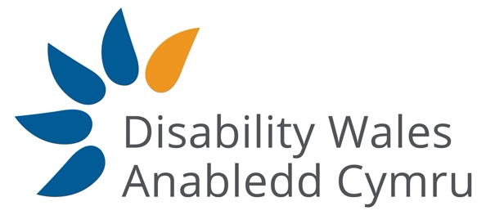

ACCESS TO ELECTED OFFICE FUND WALES

The Access to Elected Office Fund Wales (AEOFW)seeks to remove the barriers faced by disabled people seeking elected office by providing financial assistance towards the cost of reasonable adjustments and support. The fund is administered by Disability Wales with funding from the Welsh Government.

The Welsh Government has approved funding for a pilot scheme to fund reasonable adjustments and support for disabled candidates seeking election to the Senedd Cymru 2021 election and in the 2022 Local Government elections.

Who is eligible?

Disabled people standing for election. The fund is to support disabled candidates with the additional costs associated with seeking elected office.

For the 2021 Senedd Cymru election you can apply if you are eligible to stand and have or intend to declare yourself as a candidate. You can apply whether you are standing for a political party or as an independent.

What expenses can be claimed?

You can apply for assistance with the additional cost of support to overcome impairment related barriers that would enable your participation in the election. This could include:

- Assistive aids, equipment and software. Adaptations to equipment.
- Training in the use of specialist equipment and software.
- Travel around the constituency if you cannot use public transport.
- Personal assistance Communication support workers such as BSL, Interpreters, Palantypists and Lip speakers

How to apply?

First you should consult the Electoral Commission website to confirm that you are eligible to stand in the election. Once you have confirmed your eligibility and intend to stand you should contact Disability Wales.
Shortly after you register your interest we will contact you to arrange a time we can thoroughly discuss your application. At this point we will also discuss your access requirements, if applicable, you may want to gather any information you think is useful – such as previous receipts or quotes for travel or assistive technology.

Due to the likely timescales for the 2021 Senedd Cymru election expected on 6th May it is important that you register your interest as early as possible and applications should be received before the 5th March 2021.Though in exceptional cases, such as late nomination or substitution for withdrawn candidates, we will consider later submissions. Early submission is necessary to ensure support can be arranged in time.

How are decisions made?

Once your application is received Disability Wales staff will calculate the type and amount of support required. This will be set out in a document which we will ask you to approve. An anonymised version will be presented to the Decision Making Panel, which consists of members with lived experience of disability and making reasonable adjustments. They will review your application against the fund criteria.

We will notify you of the decision. If you are successful you will receive an award letter and a copy of our terms and conditions which we will ask you to sign and return. If you are unsuccessful you will be given feedback and Disability Wales will discuss your options.

How to contact us?

Telephone: 029 2088 7325 Email: info@disabilitywales.org

