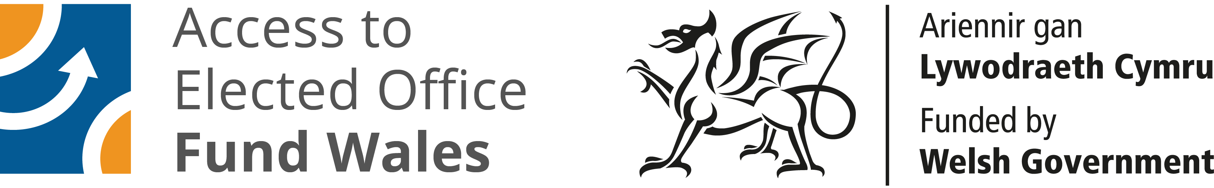

ACCESS TO ELECTED OFFICE FUND WALES

The Access to Elected Office Fund Wales seeks to remove the barriers faced by disabled people seeking elected office by providing financial assistance towards the cost of reasonable adjustments and support. The fund is administered by Disability Wales with funding from the Welsh Government.

Following the successful launch of the Fund for the 2021 Senedd Cymru Election Welsh Government has given approval for the Fund to be made available to disabled candidates standing in the 2022 Welsh Local Government Elections.

Who is eligible?

Disabled people standing for election. The fund is to support disabled candidates with the additional costs associated with seeking elected office. For the 2022 Local Government elections you can apply to the Fund if you intend to stand for election as a councillor for one of the 22 borough, city or county councils or for your community or town councils.

You can apply whether you are standing for a political party or as an independent.

What expenses can be claimed?

You can apply for assistance with the additional cost of support to overcome impairment related barriers that would enable your participation in the election. This could include:

- Assistive aids, equipment and software, adaptations to equipment an training in its use
- Travel around the constituency if you cannot use public transport.

- Personal assistance

- Communication support workers such as BSL, Interpreters, Palantypists and Lip speakers

Here are some examples of the type of additional costs that disabled candidates can apply for:

- Dyfrig is severely sight impaired and finds it difficult to negotiate the obstacles in the way when leafleting and canvassing the houses inhis ward. He can apply to the fund for financial assistance for a Personal Assistant to accompany him when canvassing and leafleting.

- Bethan is a wheelchair user and faces barriers to the use of public transport to get around her ward to canvas and attend political hustings. She can apply to the fund to cover the additional costs of taxis.

- Habib has dyslexia and has difficulty reading and respomdingto emails from voters. He can apply to the fund for screen reader assistive technology to read his emails.

- Denisa is hearing impaired,and she feels excluded from political hustings because without a BSL interpreter she is unable to follow and contribute to the debate. She can apply to the Fund for financial assistance with the cost of a BSL interpreter.

The financial assistance awarded by the Fund is available to meet costs incurred from the close of nominations to the declaration of the election result.

How to apply?

First you should consult the Electoral Commission website to confirm that you are eligible to stand in the election. Once you have confirmed your eligibility and intend to stand you should contact Disability Wales.

How are decision made?

Once your application is received Disability Wales staff will calculate the type and amount of support required. This will be set out in a document which we will ask you to approve. An anonymised version will be presented to the Decision Making Panel, which consists of members with lived experience of disability and making reasonable adjustments. They will review your application against the fund criteria.

We will notify you of the decision. If you are successful you will receive an award letter and a copy of our terms and conditions which we will ask you to sign and return. If you are unsuccessful you will be given feedback and Disability Wales will discuss your options.

How to contact us?

Telephone: 029 2088 7325
Email: accesstopolitics@disabilitywales.org

