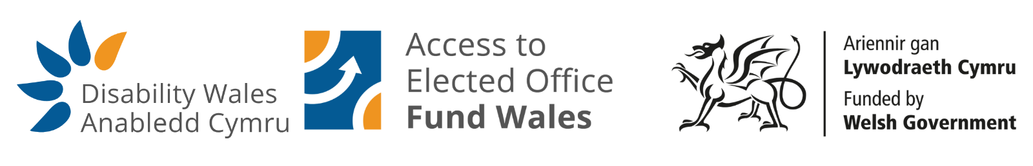
Access to Elected Office Fund Wales - Application Form

About this form

This form is for the Access to Elected Office Fund Wales. It provides financial support to help disabled people overcome impairment-related barriers to take part in elections.

It is for people who want to stand as candidates in local Government Elections (May 2027), including:
  - Borough, City or County Councils
  - Community or Town Councils

Before you apply

There are different rules about who can stand in each type of election. You should check you are eligible before applying.
- You should read the Electoral Commission guidance: https://www.electoralcommission.org.uk/our-guidance/candidate-or-agent/local-elections-wales.
- You can read the Access to Elected Office Fund guidance on the Disability Wales website at: https://www.disabilitywales.org/projects/access-to-elected-office-fund-wales/ or email: electedofficefund@disabilitywales.org.
- It may also be helpful to read Disability Wales’s Access to Politics Toolkit. This can be found on the website.
- If you are a member of a political party, there may also be a specific contact in the party who may be able to help you.

Getting help with your application

If you need support, Disability Wales staff can help you complete the form via email, a phone call, a Microsoft Teams meeting or a Zoom meeting. You will be asked to check and approve it before it is sent.

After you apply

- Disability Wales will review your application and may contact you for more information.
- An independent decision panel made up of people with lived experience of being disabled will assess your application.
- Your personal details and political affiliation will not be shared with the panel members. We will ideally aim to respond within no more than 10 working days.

Decision process

After the panel reviews your application, please be aware that the panel members may have some extra questions that need answering to help them help you.
- If successful: you will receive an award letter and instructions as soon as possible.
- If unsuccessful: you will receive feedback and can revise and resubmit your application.

Important

Please apply as early as possible so we can review your application and arrange provisional support before the election.

Please include as much detail as you can - for example, if you would like to use a particular PA provider, Interpreter or taxi company, please try to include any estimated costs.

You should also include details of how this support will help you to overcome impairment-related barriers. This will help us process your application more quickly.

Section 1: About You

Full Name:
Email Address:
Phone Number:
Address:

Preferred contact method (please choose all that apply):
☐ Email
☐ Phone
☐ Post
☐ Other (please specify):

Do you have any communication needs?
(e.g. large print, phone calls only, etc.)

May we leave you voicemails if we need to?

☐ Yes ☐ No

Section 2: Your Election Information

Your current status:
☐ Confirmed party candidate
☐ Seeking party selection
☐ Independent candidate
☐ Planning to stand as an independent candidate

Council (if known):
Ward (if known):
Area type:
☐ Rural ☐ Urban

Section 3: Support You Need

For each support request, please think about:
- The support that you need
- The impairment-related barrier this will assist you to overcome
- Estimated costs (if known)

Which of the following do you need help with? Please choose all that apply.
☐ Assistive technology (e.g. equipment, software/apps, training)
☐ Travel Support (e.g. taxis and mileage)
☐ Personal Assistance (e.g. knocking on doors, posting leaflets in letterboxes etc)
☐ Communication Support (e.g. a BSL Interpreter or Palantypist)

What support do you need?

How will you use it?

Do you know any estimated costs?

☐ Yes ☐ No

If yes, please give details:

Please note: Support workers/personal assistants cannot campaign on your behalf. This means that a Personal Assistant/Support Worker can assist or enable the candidate to represent themselves to a voter, but the personal assistant shouldn't advocate for or represent the candidate's views.

For example, they may:
- help guide you around your ward if you have difficulty navigating the environment unassisted
- interpret for you if BSL is your first language
- help you locate letterboxes if you are visually impaired
- read and mark a list of numbers for a telephone canvas for you if you are dyslexic.

But you cannot employ someone to canvas (i.e. advocate for or represent you on your behalf as it this an offence in Electoral Law).

Section 4:
Is there anything else you would like us to know? (Optional)

Section 5: Eligibility Confirmation

Please select:
☐ I confirm I am eligible to stand in this election
☐ I confirm the information I have given is true to the best of my knowledge

Section 6: Consent

Do you give permission for us to contact your political party?
☐ Yes ☐ No
☐ I am not a member of a political party

If yes:
Party name:
Your membership number (optional):
Contact name:
Phone:
Email:

May we share information about the support you have applied for? For example, “The candidate has applied for a BSL Interpreter to attend meetings and help them when canvassing.”

☐ Yes ☐ No

Disability Wales is committed to protecting your privacy. We will store your personal data and responses as part of the application process. Your personal data will always be kept confidential. For further information on how DW stores personal data and complies with the UK General Data Protection Regulation (GDPR) and Data Protection Act 2018, please read our privacy notice, which is included on our website: https://www.disabilitywales.org/privacy-notice/.

Please send your completed form to electedofficefund@disabilitywales.org. You can also use this email address to get in touch if you need support to complete the form or have any questions.

