Easy Read Survey

Getting accessible social housing

We want to know what you think

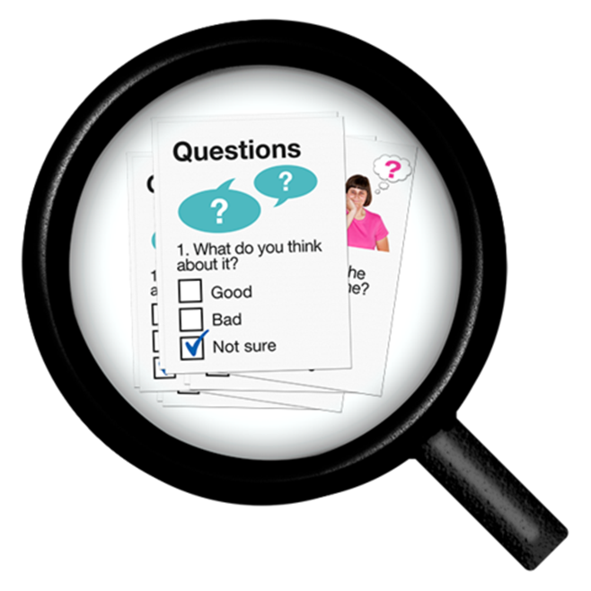

This is an easy read version of Disability Wales’ Accessible Housing Register Survey 2019.
December 2019

What this survey is about

We are Disability Wales.

We are doing this survey for Tai Pawb and Gwent Regional Partnership Board.
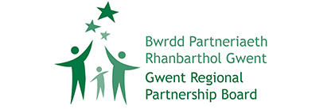
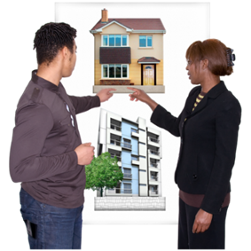 | We want your views please.  We want you to tell us the good and bad things about getting accessible social housing.  Accessible social housing means council houses that are built to help people live in an independent way.
 | We also want you to tell us how to make things easy for you when you ask for accessible social housing.

Who this survey is for?
This survey is for:

- Disabled people
- Older people
- Families with disabled children

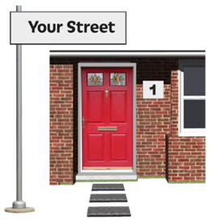 | We want you to answer the questions if:  - you live in Blaenau Gwent, Caerphilly, Monmouthshire, Newport or Torfaen
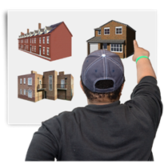 | - you were given accessible social housing in the last 5 years
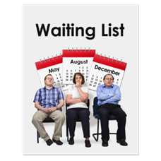 | - or you are on a waiting list for accessible social housing.
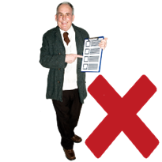 | You do not have to answer the questions if you have not asked for accessible housing.

Filling in this survey

 | This survey should take about 20 minutes to fill in.
 | You do not have to fill in every part of the survey.
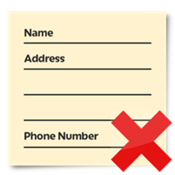 | You do not have to tell us your name or contact information.

Questions
 |  | - Where do you live? Tick 1 box.
 | Blaenau Gwent |  | ☐
 | Caerphilly |  | ☐
 | Monmouthshire |  | ☐
 | Newport |  | ☐
 | Torfaen |  | ☐

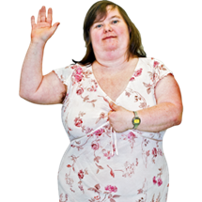 | - In the last 5 years have you asked for an accessible house?
 | Yes ☐ | No ☐

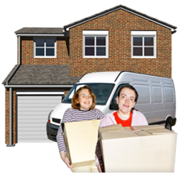 | - Were you given an accessible house?
 | Yes, I was given a house ☐ | No, I am still waiting for a house ☐

- Before you asked for accessible social housing, did you know about the accessible housing register?
Housing providers use the accessible housing register to match people to the right house in the local area.

Yes ☐ | No ☐

 | - How did you ask for accessible social housing?
 | At your local council offices | ☐
 | With your housing provider | ☐
 | By telephone | ☐
 | By post | ☐
 | Online | ☐

If you asked for accessible social housing in a different way please tell us:
- Did you find it easy to ask for accessible social housing?

Very difficult | Quite difficult | OK | Quite easy | Very easy
☐ | ☐ | ☐ | ☐ | ☐

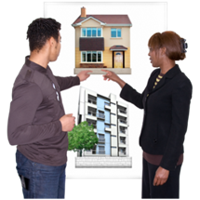 | - Were you told how accessible social housing is shared out?
 | Yes ☐ | No ☐

- Did an Occupational Therapist or Housing Officer assess your needs?
An Occupational Therapist is someone who helps you to do everyday tasks if you are having problems.

 | Yes ☐ | No ☐

 | If yes, do you feel your views and needs were listened to?
 | Yes ☐ | No ☐ | A bit ☐

 | - Did your local authority or housing provider give you easy read information about housing?
 | Yes ☐ | No ☐ | Not needed ☐

Please only answer the questions in this green box if you are still waiting for a house:

 | 11. Does your housing provider keep you up to date about your housing?
 | Yes ☐ | No ☐

 | 12. How long have you been waiting for an accessible house?
 | Less than 6 months | ☐
 | 1 year or less | ☐
 | 2 years or less | ☐
 | 3 years or less | ☐
 | 3 years or more | ☐

 | 13. Were you offered a house that did not meet your access needs?
 | Yes ☐ | No ☐
 | If you want you can tell us why the house was not right for you:

Please only answer the questions in this purple box if you have already been given a house:

 | 13. Did your housing provider keep you up to date about your housing?
 | Yes ☐ | No ☐
 | How often did you get information about your housing?

 | 14. How long did you have to wait for your accessible house?
 | Less than 6 months | ☐
 | 1 year or less | ☐
 | 2 years or less | ☐
 | 3 years or less | ☐
 | 3 years or more | ☐

 | 13. Were you offered a house that did not meet your access needs?
 | Yes ☐ |  | No ☐
 | If you want you can tell us why the house was not right for you:
 |  | 14. Does your house meet your access needs now?
 |  | Yes ☐ |  | No ☐
 |  | If you ticked no, please tell us why the house is not right for you:

 | 15. What support and advice did you get when you were trying to get accessible social housing?
 | Advice and support to ask for accessible social housing | ☐
 | Support to understand the application process | ☐
 | Support to look at houses | ☐
 | Advice and support to move into a house | ☐
 | No support was offered | ☐
 | If you did not get any help please tell us about it:

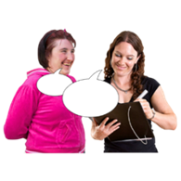 |  | 16. Let us know what you think about the support you had.
Did you feel that you were given enough information about your housing options?

No, definitely not | No, not really |  | Not sure | Yes, mostly | Yes, definitely
☐ | ☐ |  | ☐ | ☐ | ☐

Did the housing provider understand your housing needs?
No, definitely not | No, not really | Not sure | Yes, mostly | Yes, definitely
☐ | ☐ | ☐ | ☐ | ☐

Did you get to choose the kind of house you want to live in?
No, definitely not | No, not really | Not sure | Yes, mostly | Yes, definitely
☐ | ☐ | ☐ | ☐ | ☐

Overall, what was it like to ask for accessible social housing?
Terrible | Bad | Ok | Good | Very good
☐ | ☐ | ☐ | ☐ | ☐

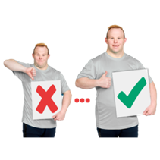 | 17. What is 1 thing you think could be better about asking for accessible social housing?

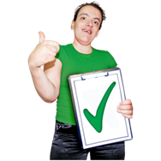 | 18. What did you like most about asking for accessible social housing?

19. Is there anything else you would like to say about asking for accessible social housing?

Finishing the survey
 | Thank you for filling in our survey.
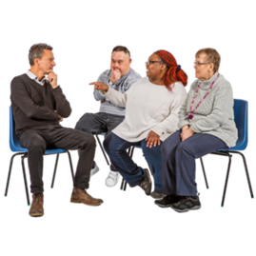 | You can tell us more about your experiences at the focus group we run.
 | If you want to join our focus group, please tell us your name and phone number.
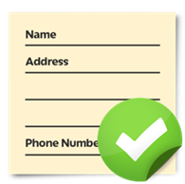 | If you would be happy for Tai Pawb to contact you please tell us your name, phone number and email address in the boxes below.
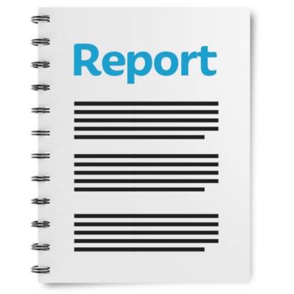 | Your answers will help us to write a report. This report will be given to the Gwent Regional Partnership Board.  A report is a piece of information written on all the proof one collects.
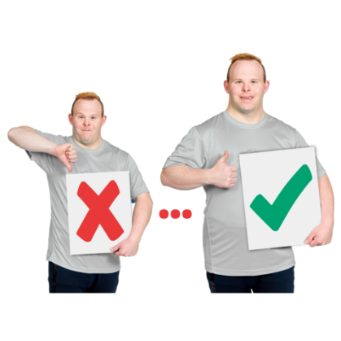 | This report will say about things that work well and things that do not work when asking for accessible social housing.
 | The report will also say what must be done to make it easy for people to ask for accessible social housing in different places.

Your full name:

Your phone number:

Your email address:

Thank you

