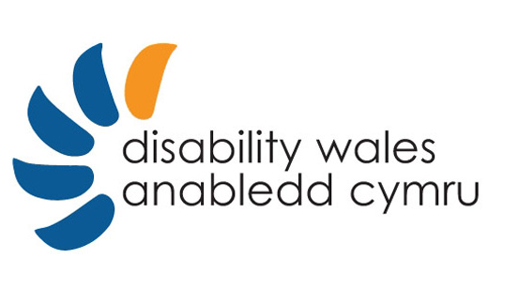 |  | 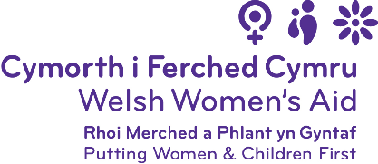
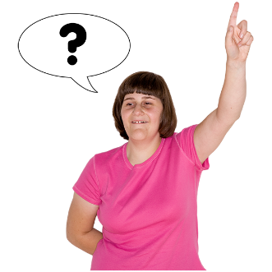 | Welsh Women's Aid and Disability Wales
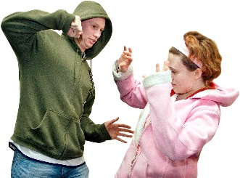 | - We want to know if someone has ever been violent to you.
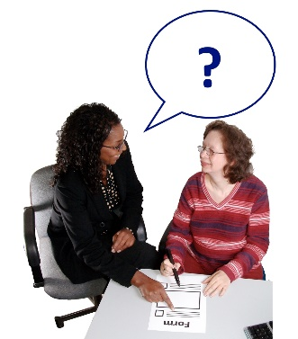 | - We want to know who you told and what they did.

 | We would like to know about:
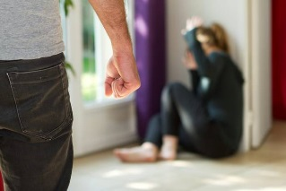 | Violence Against Women
 | Domestic Abuse
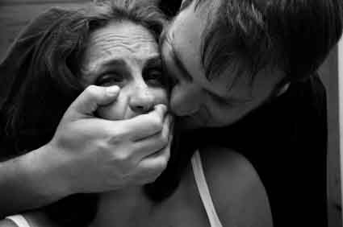 | Sexual Violence

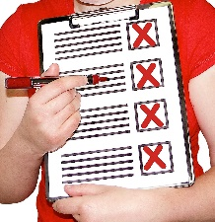 | Here are some examples of what we mean:
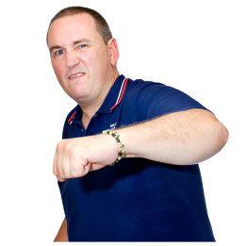 | Hitting, punching, kicking.
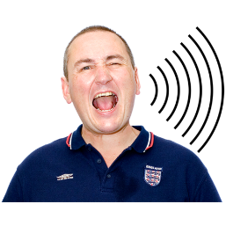 | Shouting, bullying.
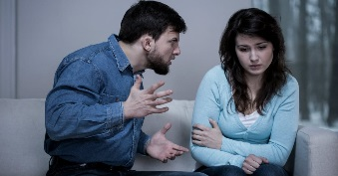 | Telling you what you can and can’t do.
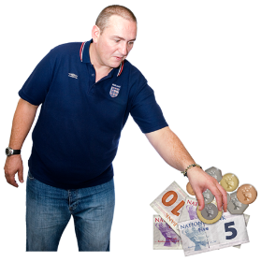 | Taking your money.
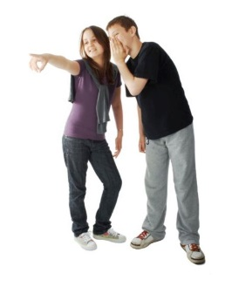 | Saying you are stupid or ugly and no-one likes you.
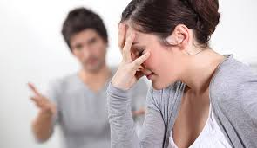 | Telling you what to do and not leaving you alone.
 | Touching your body when you don’t want it.
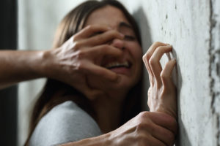 | Making you have sex when you don’t want it.
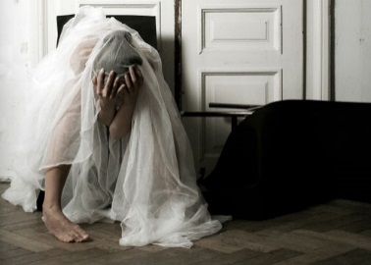 | Saying you must marry someone you don’t want to.
 | Making you watch sex videos when you don’t want to.

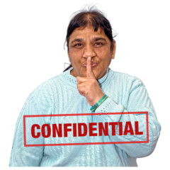 | You do not have to give your name.
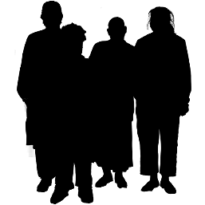 | We will not know who you are.
 | You don’t have to answer all the questions.

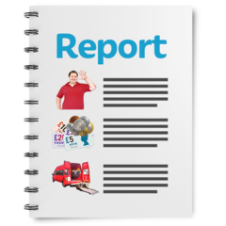 |  | We will write a report to the Welsh Government.
 |  | We will tell them:
 |  | What went when you reported what happened.
 |  | What did not go well when you reported what happened.
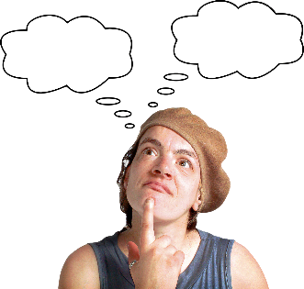 |  | What needs to change.
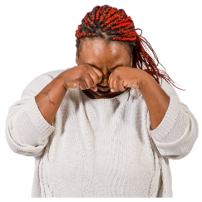 |  | If you get upset and want to talk to someone, you can call Live Fear Free.
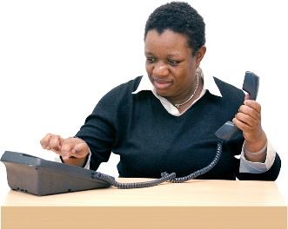 |  | Live Fear Free is a FREE Helpline.
 |  | Here is how you can get in touch with them:
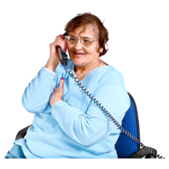 |  | Helpline - 0808 8010 800
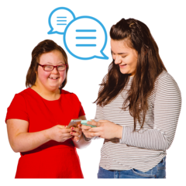 |  | Text - 078600 77333
 |  | Email - info@livefearfreehelpline.wales
 |  | Live chat - livefearfree.gov.wales
 |  | Thank you for your help.
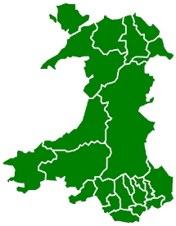 |  | - Where in Wales do you live?
North |  |  | South
Mid |  |  | West

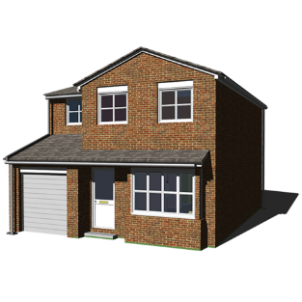 |  | - Do you live in the countryside or in a town?
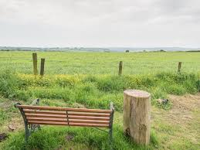 Countryside |  |  | 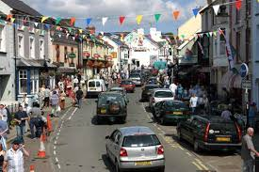Town

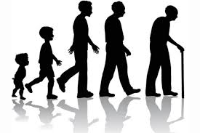 | - How old are you?
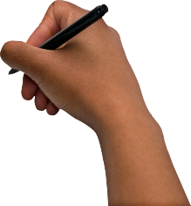

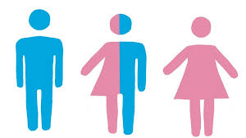 |  |  | - What is your gender?
Female |  |  |  | Male
Non-binary |  |  |  | Don’t want to say
My own term (please say).
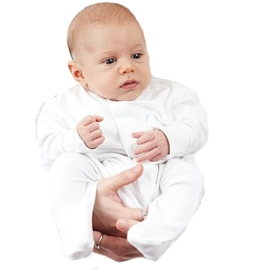 |  | - Is your gender the same as it was when you were born?
Yes |  |  | No |  | Don’t want to say

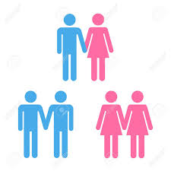 | - Who do you fancy or have sex with?
Men |  |  |  | Women
Both |  |  |  | Don’t want to say
Other (please say)
 |  | - What is your ethnic background?
White: British (Welsh/English/ Scottish/ Northern Irish) |  |  | White: Irish
White: Irish or Gypsy Traveller |  |  | Mixed: White and Black Caribbean
Mixed: White and Black African |  |  | Mixed: White and Asian
Asian or Asian British: Indian |  |  | Asian or Asian British: Pakistani
Asian or Asian British: Bangladeshi |  |  | Asian or Asian British: Chinese
Black or Black British: Black Caribbean |  |  | Black or Black British: Black African
Don’t want to say
Other (please say)

 |  | - Do you have a religion?
Yes
Please tell us what religion
No
Don’t want to say

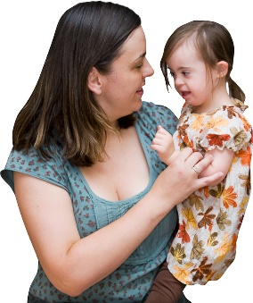 |  | - Do you have children?
Yes |  |  | No
Non-binary |  |  | Don’t want to say

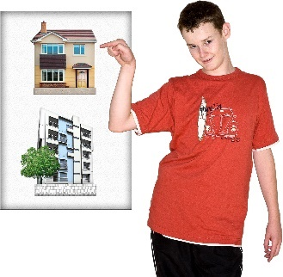 |  | - What type of place do you live in?
Own my house |  |  | Rent from the council
Rent from a landlord |  |  | Housing association
Supported Housing |  |  | Sheltered Housing
Refuge |  |  | Hostel
With family
Other (please say)

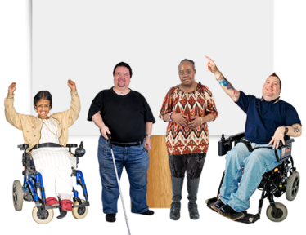 |  | - Do you have a disability?
Yes |  |  | No

 |  | - Please tell us about your disability.
Mental Health |  |  | Learning Difficulty
Learning Disability |  |  | Physical Disability
Visual impairment |  |  | Hearing impairment
Chronic Health Condition |  |  | Neurological impairment
Prefer not to say
Other (please say)

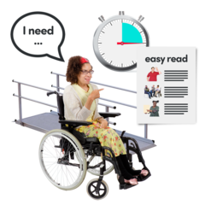 |  | - Which of these do you use?
BSL interpreter |  |  | Sign Along
Alternative formats for information e.g. Easy Read |  |  | Personal assistant
Support worker |  |  | Assisted Technology e.g. talking mats
Home adaptation
Other (please say)

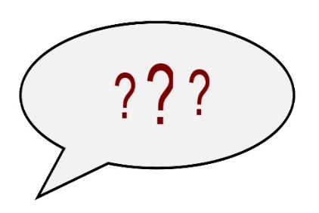 |  | Has anyone done these things to you?
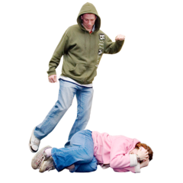 |  | - Physical Abuse e.g. hitting, pushing, thumping, kicking
Yes |  |  | No
Don’t want to say

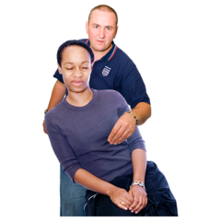 |  | - Sexual Abuse e.g. touching your private parts, making you have sex when you don’t want to, making you watch porn films.
Yes |  |  | No
Don’t want to say

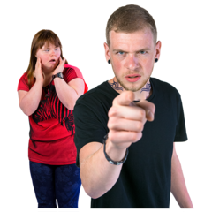 |  | - Verbal Abuse e.g. making fun of you, telling you you’re rubbish, making you feel useless.
Yes |  |  | No
Don’t want to say

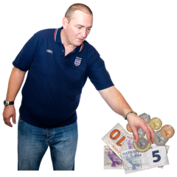 |  | - Financial Abuse e.g. taking your money, making you pay for things all the time
Yes |  |  | No
Don’t want to say

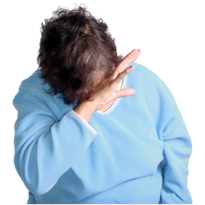 |  | - Emotional Abuse e.g. bullying you, not letting you see your friends and family, making you unhappy
Yes |  |  | No
Don’t want to say

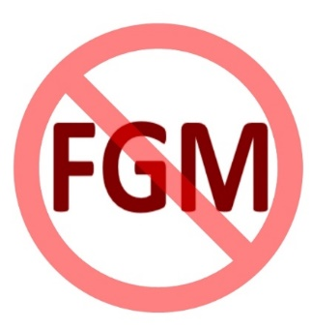 |  | - Female Genital Mutilation - this means cutting your private parts
Yes |  |  | No
Don’t want to say

 |  | - Forced Marriage - this means being made to marry someone you don’t want to.
Yes |  |  | No
Don’t want to say

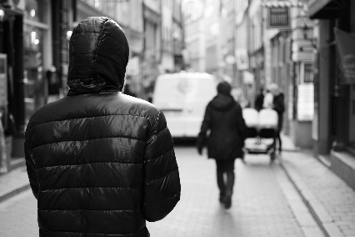 |  | - Stalking e.g. following you around and checking up on you all the time.
Yes |  |  | No
Don’t want to say

 |  | - Has anyone ever done anything bad to you that we haven’t asked about?
Yes |  |  | No
If you said yes please tell us more:

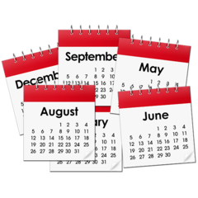 |  | - If any of these things happened to you, how long did it go on for?
 |  | - Who did these things? Was it 1 person or more than 1 person?
  1 person |  |  |   More than 1 person

 |  | - Were they:
  Male |  |  |  Female
Don’t know
 |  | - Who was it?
Partner |  |  | Parent
Other relative |  |  | Stranger
Carer |  |  | Support Worker
Personal Assistant |  |  | Someone who works in your care home
Someone else (please say who)

I don’t want to say
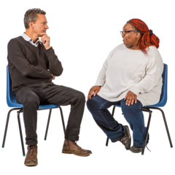 |  | - Who did you tell about it?
No one |  |  | Friend
Family |  |  | Carer
Support Worker or PA |  |  | Someone who works where I live
Work colleague |  |  | Doctor or Nurse at GP surgery
Doctor or Nurse (A&E services) |  |  | Solicitor
Social Services |  |  | Police
Specialist worker |  |  | Disability organisation
Housing Services
Someone else (please say who)
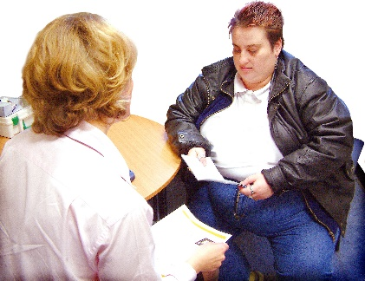 |  | - Did they put you in touch with a special abuse service e.g. Women’s Aid?
Yes |  |  | No
If you said yes please tell us who?

 |  |  | - What did the specialist service offer you?
A safe place to  live |  |  |  | A drop-in centre
Counselling |  |  |  | Training
Nothing
Something else (please say what)
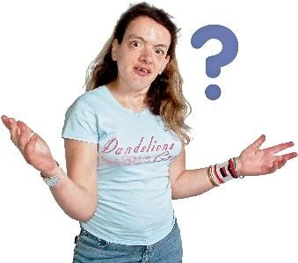 |  | - If you didn’t get any of these things, can you say why?
They did not understand my  disability |  |  |  | The service or refuge was full
There was nothing for me nearby |  |  |  | I couldn’t get there
If I left my area I’d lose my care package
Other (please say)

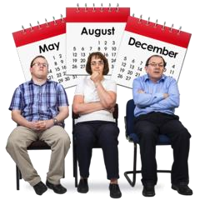 |  | - Did you have to go on a waiting list?
Yes |  |  | No
If you said yes please tell us how long you had to wait

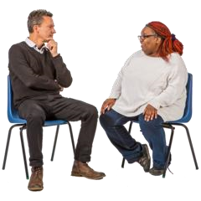 | - Did the person you told believe you?
Yes |  | No
- If they didn’t believe you did they say why?

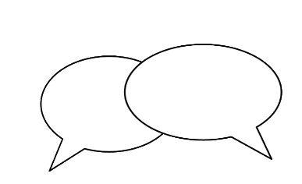 | - If you told someone, how did you do it?
999 call |  | 101 call
Phoned a helpline |  | In person
By text or email
Other (please say)

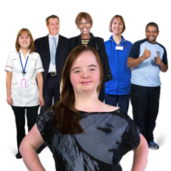 | - Did you get good support?
Yes |  | No
Please say more

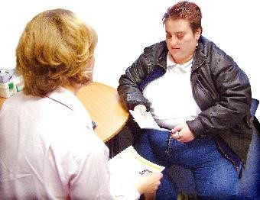 | - When you told someone what did they do?
They just listened |  | They did something to help
Please say more

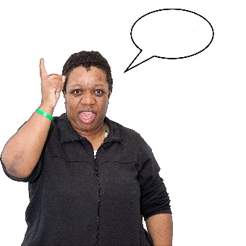 | - What would make it easier to report abuse and violence?
If I knew more about services that could help me
If information was in Easy Read
If I had the phone number or email of a person who could help
If they were nicer to me and if I had better support afterwards
If I knew they would believe me
If I knew I would get the care and support I needed
If services and people understood my needs
If services and people treated me the same as everyone else - not different because of my disability
Something else…
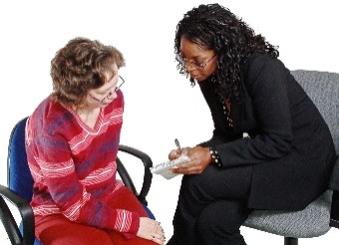 | - What happened after you told someone about the abuse?
I moved away from home
I left my partner
I went to a care home
I moved to a refuge
There were child protection issues
We went to mediation
I got medical care
Nothing changed
Something else…
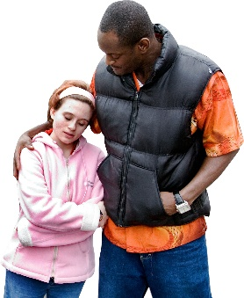 |  | - Did you get a care package or extra support?
Yes |  |  | No
If you said yes please say what

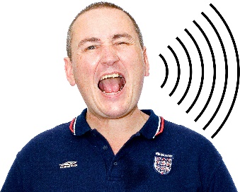 |  | What happened to the person who abused you?
Nothing
They got an injunction from a judge
They got a community order
They got a suspended sentence(this means they were found guilty but didn’t go to jail)
They have been charged but haven’t been to court yet
They were arrested but let go
They went to jail
They were sent on a training course to help them not be violent
They stayed in our home
They stayed in our home and I moved out
They kept the children
They were allowed to see the children
Something else…
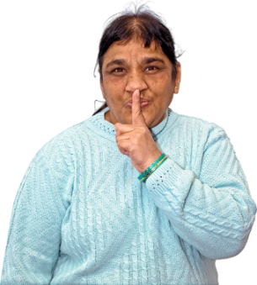 | Did any of these things stop you telling someone?
Last time I told someone they did not help me
I did not know what happened was wrong
I did not think it was serious
I did not want people to know about it
I felt alone
I did not think anyone would understand
I was worried about money
I was worried about losing benefits
I needed help to speak but there wasn’t any
I needed disability transport but there wasn’t any
I was frightened it would make things worse
I was frightened the person who hurt me would get into trouble
I was scared of losing my children
I was scared I would have to leave my home with nowhere else to go
I was worried about what would happen to the children
I was worried that I would lose the care and support I needed
I was worried there would be nowhere to for me to live that would meet my needs
Something else…

- Is there anything else you would like to say?

 | Thank you for answering these questions.
 | If you have any questions about this survey you can talk to Hannah Mason at Welsh Women's Aid.
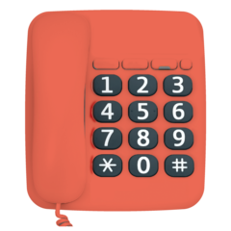 | Her phone number is  02920541551
Her email is
HannahMason@welshwomensaid.org.uk

