Universal Credit Factsheet

What is Universal Credit?

Universal Credit (UC) is a new benefit that will replace 6 current benefits means tested benefits for working aged people. You may be eligible to claim UC if you are on a low income or unemployed.
Universal Credit is gradually being rolled out across the UK in stages. When your postcode moves to Universal Credit you can no longer make a new claim for tax credits, Housing Benefit or out-of-work benefits like Income Support, as all these benefits are now part of UC.

Families with three or more children making a new benefit claim are an exception to this rule. They can continue to make new claims for existing benefits and tax credits until at least February 2019.

When will I be affected?

The image below shows the timeline for Wales.
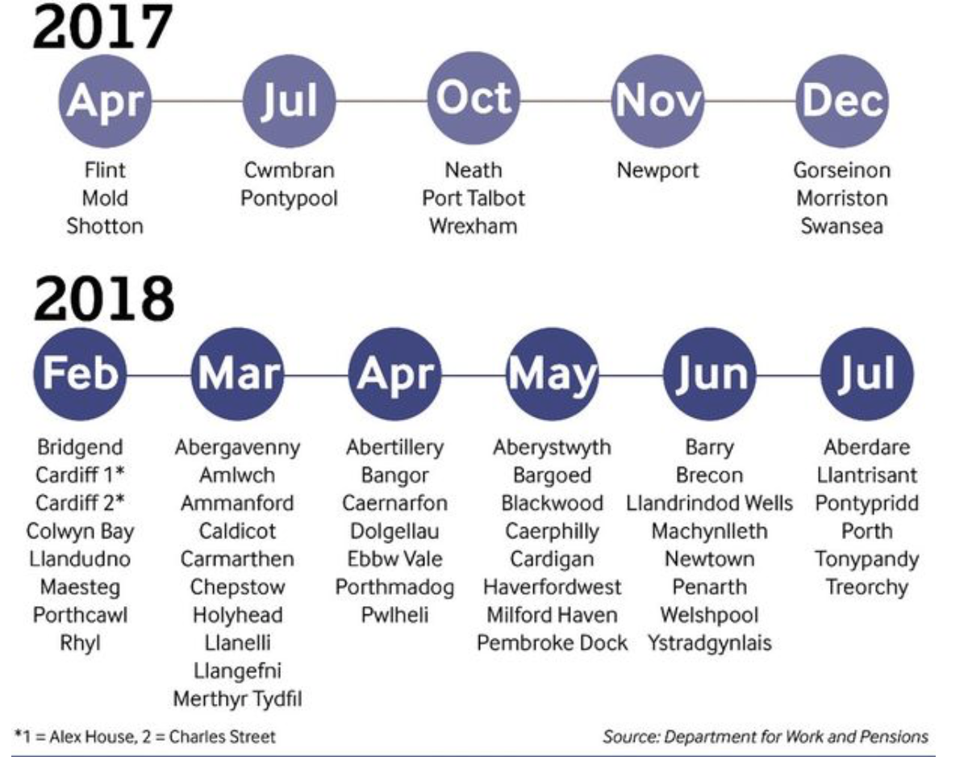

Eligibility:

To apply for UC you must be
- aged 18 or over unless:
  - you have limited capability for work or you have medical evidence and are waiting for a Work Capability Assessment
  - you’re caring for a severely disabled person
  - you’re disabled and entitled to Disability Living Allowance (DLA) or Personal Independence Payment (PIP) and have limited capability for work
- under the qualifying age for pension credit (the state pension age is under reviewed and might be changed in the future)
- live in Great Britain
- not be subject to immigration control
- usually not be in full-time education, unless you are eligible with
  - attendance allowance,
  - disability living allowance or
  - personal independence payment
- have accepted a claimant commitment unless the claimant commitment does not apply to you

If you have a partner (including a same-sex partner), you must normally make a ‘joint claim’ for Universal Credit.

If one of you is over pension credit qualifying age you may still qualify for Universal Credit.

You (and your partner if you are making a ‘joint claim’) must not have capital/savings of more than £16,000.

How much can I get from the UC?

The amount of Universal Credit you are paid depends on you (and your partner's) circumstances. It is worked out on a monthly basis by comparing what the law says you need - your maximum amount with your actual income/earnings and savings. Your maximum amount is made up of a standard allowance, which depends on your age and whether you are claiming as a single person, a couple or if you have children.

You can get additional Universal Credit if you have a ‘limited capability for work and work-related activity’. This is determined by a ‘work capability assessment’ (more information below)

Standard allowance rates
Your circumstances | Monthly standard allowance
Single and under 25 | £251.77
Single and 25 or over | £317.82
In a couple and you’re both under 25 | £395.20 (for you both)
In a couple and one or both are aged 25 or over | £498.89 (for you both)

Additional allowance:

If you have children
How much you’ll get | Extra monthly amount
For your first child | £277.08 (born before 6 April 2017)  £231.67 (born on or after 6 April 2017)
For your second child | £231.67 per child
If you have a disabled or severely disabled child | £357.78 to £649.38 (this includes the amount for your first or second child)
If you need help with childcare costs | up to 85% of your costs (up to £646.35 for one child and £1,108.04 for 2 or more children)

If you have an impairment or health condition or care for an adult who does
How much you’ll get | Extra monthly amount
If you have limited capability for work and work-related activity | £318.76
If you have limited capability for work and you started your Universal Credit or Employment and Support Allowance (ESA) claim before 3 April 2017 | £126.11
If you care for a disabled person | £151.89

Housing costs
You could get money to help pay your housing costs. How much you get depends on your circumstances.
The payment can cover:
- rent
- mortgage interest
- some service charges
- interest on a loan secured against your home

Work Capability Assessment

You might get an extra amount of Universal Credit if you have a health condition or impairment that limits your ability to work.
Your monthly payment is based on your circumstances, for example your health condition or impairment, income and housing costs.

If you made a new Universal Credit claim on or after 3 April 2017 and have limited capability for work, you won’t get the extra amount.

After you apply for Universal Credit, you need to complete the Universal Credit capability for work questionnaire UC50 (link https://www.gov.uk/government/publications/uc50-form-universal-credit-capability-for-work-questionnaire ). You’ll be sent a paper copy of the form with your appointment letter or you can fill it in online and print it.
Fill in the form and send it to the Health Assessment Advisory Service. The address will be on your appointment letter.
You’ll then have a Work Capability Assessment. This is to assess to what extent your impairment or health condition affects your ability to work.
Based on the outcome of the assessment, you’ll be placed in one of 3 groups:
- fit for work
- limited capability for work - you can’t work now, but with the correct support you may be able to work in the future
- limited capability for work and work related activity - you can’t work now and you’re not expected to be ready to work in the future
- Terminal illness: If you’re not expected to live more than 6 months, you’ll get the extra Universal Credit amount.

How the assessment affects your claim:
- If you’re fit for work, you’ll need to agree to look for work that is suitable for your health condition, and be prepared to work.
- If you have limited capability for work, your work coach will discuss your situation and agree steps to help you start preparing for work.
- You’ll get extra money if you have limited capability for work and work related activity. You don’t need to look for work or prepare for work.

Your responsibilities:
- You’ll need to agree to certain conditions to keep getting Universal Credit. This is known as your ‘Claimant Commitment’.
- Your commitment is based on your circumstances and may be affected by the outcome of your Work Capability Assessment.
- You must report any change in circumstances straight away, including:
  - changes to your condition, for example it gets better or worse
  - a new health condition
  - any other changes, such as finding a job or moving in with a partner

How starting work affects your claim

You may still get Universal Credit if your condition changes and you can start working again.
Your payment won’t change until you earn over a certain amount.
Speak to your work coach or use a benefits calculator to find out how starting work could affect your Universal Credit payment.

How your earnings affect what you get
If you’re employed, your Universal Credit payment reduces gradually as you earn more. For every £1 you earn your payment reduces by 63p.
There’s no limit to how many hours you can work.
Use a benefits calculator to see how increasing your hours or starting a new job could affect what you get. There are different rules if you’re self-employed.

The work allowance
You can earn a certain amount before your Universal Credit is reduced if you or your partner:
- are responsible for a child or young person
- have an impairment that affects your ability to work
This is called a ‘work allowance’. Your work allowance is lower if you get help with housing costs.
Your circumstances | Monthly work allowance
You get help with housing costs | £192
You don’t get help with housing costs | £397

Example:
You have a child and get money for housing costs. You’re working and earn £500 during your assessment period. Your work allowance is £192. This means you can earn £192 without any money being deducted. For every £1 of the remaining £308 you get, 63p is taken from your Universal Credit payment. So £308 x £0.63 = £194.04. This means you earn £500 and £194.04 is deducted from your Universal Credit.

Payments
Universal Credit will be paid monthly. Usually all payments are made to you but in some circumstances your rent may be paid directly to your landlord. At the beginning of your claim you can ask for an advance payment, which you will have to repay. You may also be able to get ‘discretionary housing payments’ (DHPs) if your Universal Credit does not cover all your housing costs. You must claim a DHP from your local authority.

An online benefit calculator can be found at: https://www.gov.uk/benefits-calculators

How can I apply for UC?

You can claim Universal Credit online (https://www.gov.uk/universal-credit/how-to-claim). If you need help, you can ring the Universal Credit helpline:

Live service: 0800 328 9344
Full Service: 0800 328 5644
Welsh language (make a claim): 0800 012 1888
Welsh language (report changes): 0800 328 1744
Text-phone: 0800 328 1344 (applicant with speech or hearing impairments)
Monday to Friday, 8am to 6pm.

What document/evidence do I need to claim?
You’ll need:
- your bank, building society or credit union account details
- an email address
- your National Insurance number
- information about your housing, for example how much rent you pay
- details of your income, for example payslips
- details of savings and any investments, like shares or a property that you rent out
- details of how much you pay for childcare if you’re applying for help with childcare costs

You also have to verify your identity online. You’ll need some proof of identity for this, for example your:
- driving licence
- passport
- debit or credit card

If you don’t provide the right information when you apply it might affect when you get paid or how much you get.

What do I do if I am not happy with the amount of the allowance?

If you are not happy with the decision made about your Universal Credit you must first ask the Department for Work and Pensions to look again at the decision. This is called a ‘mandatory reconsideration’.

If you disagree with a reconsidered decision, you can then take your case to an independent appeal tribunal.

You find your local advisor to help you challenge the decision, search your local advisor here: https://advicelocal.uk

What should I do if I have already hold some types of benefit
Income-related Employment and Support Allowance is one of the benefits that Universal Credit is replacing. If you are already claiming ESA, you don’t do need to do anything. DWP will contact you when it’s time to move on to Universal Credit.

More information can be found by contacting various sources

- Department for Work and Pensions (DWP) is the primary government body you should contact regarding benefit application queries.

Telephone: 0345 608 8545 (8am-6pm)
Text-phone: 0345 608 8551
Welsh speaking: 0345 600 3018
Address: Caxton House, Tothill Street, London, SW1H 9NA

- Independent agencies

The Money Advice Service: 0800 138 7777. Monday to Friday, 8am to 8pm; Saturday, 9am to 1pm; Sunday and Bank Holidays, closed. They can provide financial related advice on claiming UC benefits.

Turn 2 Us: 0808 802 2000 Monday to Friday (8am-8pm). Benefit advice.

Citizen Advice: offer debt, benefit, housing and employment advice.
Phone: 03444 77 20 20 (same cost as calling 01/02 numbers)
Text-phone: 03444 111 445
Web chat: https://www.citizensadvice.org.uk/about-us/contact-us/web-chat-service/
Local visit: you can get in touch with your local helpers to arrange a face-to-face meeting at your home. More information can be accessed at: https://www.citizensadvice.org.uk/about-us/how-we-provide-advice/advice/what-to-bring-on-your-local-citizens-advice-visit/

Disability Benefits Helpline:
Telephone: 08457 123 456; Textphone: 08457 224 433. Monday to Friday 8am-6pm.

Disclaimer
This factsheet was produced in April 2018 and is based on the situation that UC is still being rolled out across Wales. Please be aware that in browsing this factsheet, you understand that Disability Wales has NO control in the Universal Credit application making procedure. Therefore, this factsheet is for information only. Some details in this factsheet may be eligible to change, please check with the DWP before making a claim to UC.

Disability Wales,
Brydon House, Block B
Caerphilly Business Park,
Van Road,
Caerphilly
CF83 3ED

Tel: 029 20887325
Fax: 029 20888702
Email: info@disabilitywales.org

