Speaker Biographies

Conference chair

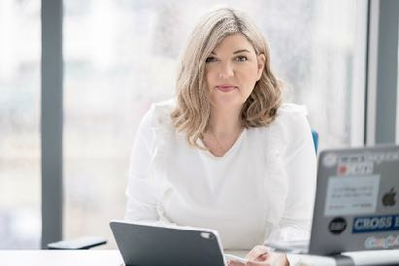
Emma Meese - Director of Community Journalism, Cardiff University

Emma has almost thirty years experience in journalism and broadcasting, with a specific understanding and strong knowledge base of the media landscape in Wales. As director of Community journalism at Cardiff University and founding director of the Independent Community News Network (ICNN), she specialises in independent and community journalism and social media for journalists. Emma sits on a number of boards and regularly advises Governments and large organisations on journalism related matters.

Keynote speakers

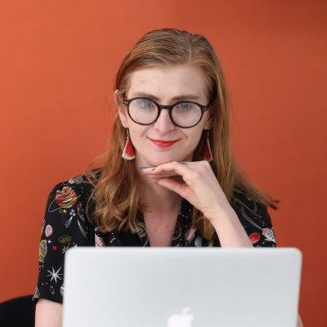
Rachel Charlton-Dailey - award-winning disability rights journalist, editor and activist.
A prominent disability rights columnist for The Daily Mirror who guest edited the series Disabled Britain: Doing it for Ourselves and founding editor of The Unwritten, a publication for disabled people to share their authentic experiences. Rachel has written for a wide range of publications and is currently trying to get the press regulator to create much needed guidelines around disability.

Dr. Natasha Hirst - freelance photojournalist specialising in social justice and equalities issues.

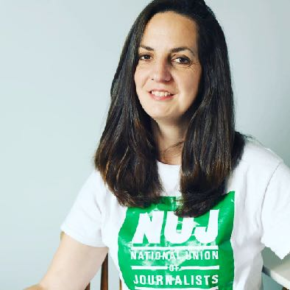
Natasha is the president of the National Union of Journalists representing disabled members on the national executive council. She is the Chair of Disability Arts Cymru and was a co-researcher on the Legally Disabled Project. She is a member of the Welsh Government Disability Rights taskforce and chaired the Access to Services (inc communications and technology) working group.

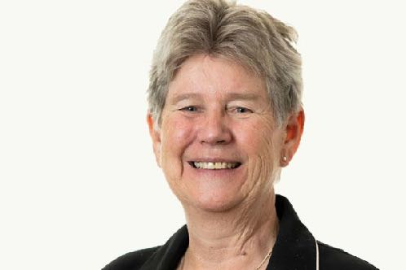
Jane Hutt MS – Minister for Social Justice and Chief Whip
Jane spent part of her childhood in Uganda and Kenya, and was educated at the University of Kent, the London School of Economics and Bristol University. She has lived and worked in Wales since 1972.
Jane was an elected member of the former South Glamorgan County Council for 12 years and was first elected to the Assembly in 1999. Between 1999 and 2005 she served as Minister for Health and Social Services in the Welsh Government. From 2005 to 2007, she was Minister for Assembly Business and Chief Whip. In the first Cabinet of the Third Assembly she was appointed Minister for Budget and Assembly Business.
In the coalition Cabinet, announced on 19 July 2007, she became Minister for Children, Education, Lifelong Learning and Skills. In December 2009 she was appointed Minister for Business and Budget, subsequently Minister for Finance until 2016 when she was appointed Leader of the House and Chief Whip at the start of the Fifth Assembly.
On 13 December 2018 Jane was appointed Deputy Minister and Chief Whip. Jane was appointed Minister for Social Justice on 13 May 2021.
Jane Hutt is an honorary fellow of Cardiff Metropolitan University and Cardiff and Vale College. She is a Welsh learner.

Dawn Bowden MS – Deputy Minister for Arts, Sport and Tourism

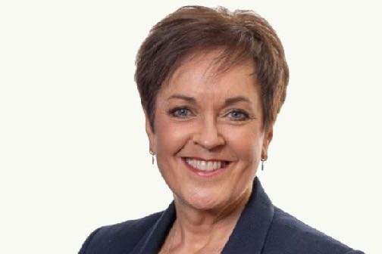
Dawn Bowden was born in Bristol and educated at St Bernadette Catholic Secondary School and Soundwell Technical College. She worked for the National Health Service between 1979 and 1982, and for Bristol City Council from 1982 to 1983. In 1989, she moved to south Wales to become the youngest and first female District Officer in the area. She rose through the ranks of her union to become the UNISON Cymru/Wales Head of Health, a position she held up to her election as Assembly Member for Merthyr Tydfil and Rhymney in May 2016. She counts amongst her proudest achievements leading on the negotiations that delivered the Living Wage into NHS Wales in 2014.

Dawn was elected as a Member of the Senedd for Merthyr Tydfil and Rhymney in May 2016. In the last Senedd term, Dawn served on the Health, Social Care and Sport; Culture Welsh Language and Communications; External Affairs and Additional Legislation; Climate Change and Rural Affairs; Children, Young People and Education and Equalities, Local Government and Communities Committees. She also Chaired the Committee on Senedd Reform and represented the Welsh Parliament at the European Congress of Regions and was a Member of the Valleys Taskforce.
On 13 May 2021 Dawn was appointed Deputy Minister for Arts and Sport and Chief Whip.

Panel members

Ryan Dean Chappell – Diversity, Sustainability and Social Purpose Leader at S4C

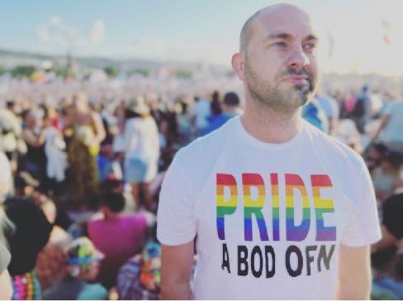
After 13 years in the Welsh primary education sector as a teacher, senior leader, assistant head and deputy head, Ryan has transferred his passion for inclusion from curriculum design to the television industry. Ryan fully embraces the challenges ahead of him at S4C as he aims to make the business, its on screen and off screen presence more inclusive and a better reflection of Wales and its people in 2023.

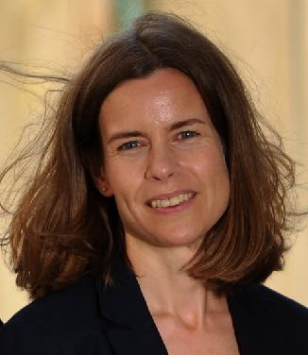

Catrin Pascoe - Editor, Western Mail

Cardiff-born and Fiji, Cyprus and Pembrokeshire schooled, Catrin joined the Western Mail as a senior reporter in 2001. She has risen through Media Wales' ranks, playing a key role in the editorial and digital development of its website WalesOnline and print titles, plus mentoring and training of its reporting team. She became Editor: Daily Content and South Wales Echo in July 2014, then Editor of the Western Mail in March 2016. She read French at Reading and Grenoble universities, then completed a postgraduate journalism diploma at Cardiff University.

Sian Gwynedd – Head of Culture and Partnerships at BBC Cymru Wales
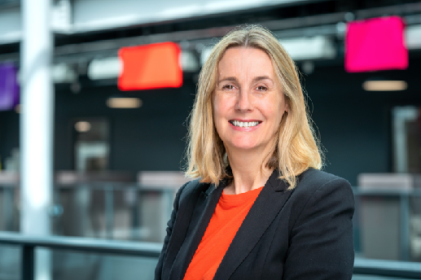
Sian has a wide portfolio of responsibilities that include commissioning Welsh language TV programmes for S4C such as Pobol y Cwm and Newyddion S4C and the delivery of Education and Bitesize content in Wales. She is also responsible for Public Engagement and oversees BBC Wales’ Diversity and Inclusion work as well as being involved with apprentices, staff training and development and partnerships.
Sian was Head of Welsh Language Programmes and Services from 2012 – 2016 and Editor of BBC Radio Cymru 2006-2012.
Sian has a background as a journalist and first joined the BBC as a researcher with Radio Cymru news. During the past 20 years she has worked in Wales as a journalist for newspapers and magazines, and as a reporter and producer for a number of radio and television news programmes. Originally from Bala in North Wales she now lives in Cardiff with her husband and two teenage children.

Disabled activist media showcase

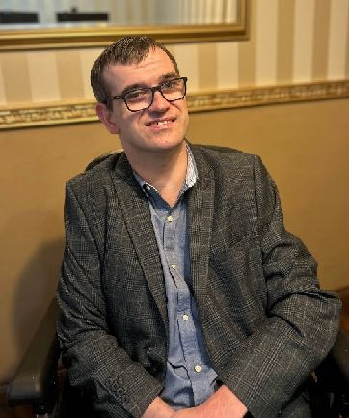
Lee Ellery – Disabled Activist
Lee works for Shaw Trust. He is also an independent disability rights campaigner helping individuals and organisations to raise awareness of the issues that affect disabled people. Lee provides support to run campaigns and help ensure disabled people’s voices are heard.

Lee has worked with many organisations over the years. He is currently working voluntarily on a Disability Action Plan for Wales with the Welsh Government. He also works voluntarily for Co-production Network Wales. Lee delivers Disability Awareness Training to students in Swansea University. He is an ambassador for Therapy for Swansea Kids.

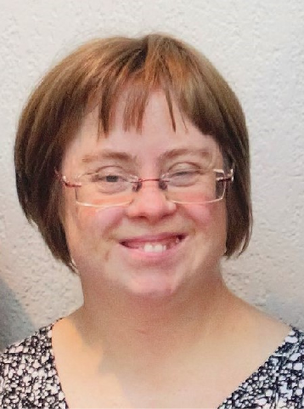
Sara Pickard – Self-advocate and Engagement Officer at Mencap Cymru
Cllr. Sara Pickard is the Engagement Officer for Mencap Cymru, she has worked there for 17 years. In 2011 Sara was elected as an independent councillor for Pentyrch Community Council. As the only person on the council with Down’s Syndrome Sara ensures the needs of disabled people are given attention.

Sara has been a focus of numerous media in her life. In 2009 & 2010 she toured with HiJinx Theatre Company as a professional actress. Her work at Mencap Cymru and as a self-advocate has seen her feature in several news stories over the years, including coverage of her speech at the United Nations, the House of Commons and when she was a Torchbearer for the 2012 London Olympics.

Through Mencap Cymru’s partnership with ITV Cymru Wales Sara was asked to take part in a 5-week work placement as a Public Affairs Assistant. This was to aid ITV Cymru Wales to understand what is required to support disabled people who may apply to become paid staff or take up placements in the future. Sara attended numerous events and fronted her own package on Wales at Six and Sharp End.

Selena Caemawr – Aubergine Cafe

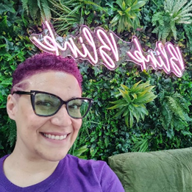
Selena Caemawr is the founder and director of the award-winning Aubergine Café CIC. They are certified in advocacy, and advice and guidance, and use these alongside their 27 years' experience working in education and support to create a safe space for Neurodivergent and other marginalised people.

