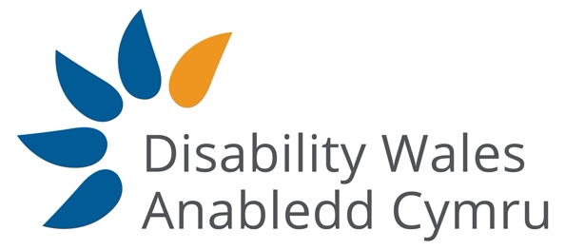

Access to Elected Office Fund Wales – Decision Panel

Access to Elected Office Fund Wales

The Welsh Government has agreed to establish an Access to Elected Office Fund on a pilot basis for the 2021 Senedd Cymru and 2022 Local Government elections.

Disabled people seeking to stand for election as candidates for the 2021 Senedd Cymru and the 2022 Local Government Elections can apply for financial assistance. Awards are made to cover impairment related costs/barriers that non-disabled people don’t face. The aim is to ensure disabled people can fight an election campaign on a more even playing field.

Role Purpose & Overview

The Decision Panel will make the award decisions on applications to the Access to Elected Office Fund Wales from disabled people standing for election as Senedd Members in the 2021 elections and as councillors in the 2022 Local Government elections. The Panel will be accountable to Disability Wales.

Panel members will:
- Be available to review recommendations and make award decisions monthly. Meetings will be held by remote participation or in facilities arranged by Disability Wales.
- Acknowledge the human rights of disabled people, as outlined under the United Nations Convention on the rights of Disabled People (UNCRDP).
- Be fair and impartial in regards to party politics.
- Treat all information contained in applications as confidential.

The Panel’s current term is expected to last up to the 2022 Local Government elections.

Person Specification
- Lived experience of disability and making reasonable adjustments.
- Knowledge of political campaigning or election administration.
- Strong communication and team working skills.
- Awareness of disabled people’s access requirements.
- Previous board or panel experience is desirable, but not essential.
- Applicants should not currently hold elected office, and or be planning to run for elected office before or during the 2021 Senedd Cymru and the 2022 Local Government electionS.

How to Apply

We have a flexible application process. You can apply by filling out the application form attached. We can take verbal application by telephone or by skype/Zoom/teams. You can also send us a video recording or any other method that communicates how you meet the person specification.

Please apply by 16th February. You can post applications to Disability Wales, Brydon House, Block B, Caerphilly Business Park, Van Road, Caerphilly CF83 3ED or e-mail them to info@disabilitywales.org
You can also contact us by phone on 029 20887325

