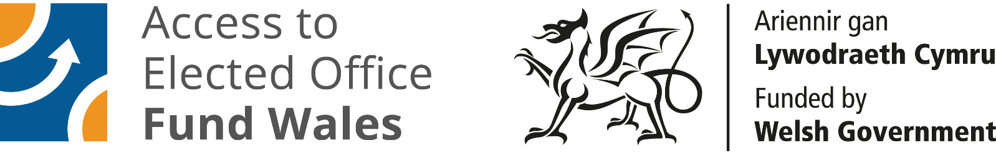
Access to Elected Office Fund Wales
Application for Financial Assistance
2026/2027 Elections

IF YOU REQUIRE THIS FORM IN AN ALTERNATIVE FORMAT - PLEASE CONTACT DISABILITY WALES.
Email: electedofficefund@disabilitywales.org
Tel: 029 2088 7325

This is an application form for the Access to Elected Office Fund Wales, which provides financial support to overcome the barriers to disabled candidates’ participation in elections. It is intended for those seeking to stand as candidates in the Senedd Elections due in May 2026 and the Local Government Elections due in May 2027. This includes those standing for election to:

- Borough, City or County Council
- Community or Town Council

There are different rules determining who is eligible to stand foreach type of council. Before you start your application, you should first visit the Electoral Commission website, to read the eligibility requirements for candidates standing for election. You can find this here https://www.electoralcommission.org.uk/i-am-a/candidate-or-agent/local-elections-wales

You should also consult the guidance about the Access to Elected Office Fund Wales on the Disability Wales website, which can be found here:
https://www.disabilitywales.org/projects/access-to-elected-office-fund-wales/
or by contacting us via email at electedofficefund@disabilitywales.org

If you have gone through the guidance, know what reasonable adjustments you need financial assistance with and feel you understand what information the Panel
requires, you can go ahead and return the completed form to electedofficefund@disabilitywales.org

If you require assistance to complete the form Disability Wales staff can go through the application form with you and complete it on your behalf. You will then be asked to approve it before submission.

Once the completed form has been received Disability Wales staff will go through your application, calculate the types and amount of support required before submission to the Panel. We may contact you to seek clarification before submission to the Panel.

The Panel will not see any information about your personal details or your political affiliation contained in Section A.

You will receive notification of the Panel’s decision shortly after it meets. If your application is successful, you will be sent an Award letter, guidance on managing your award, and a copy of our terms and conditions, which we will ask you to sign and return. If your application is unsuccessful. you will be provided with feedback on the decision. Disability Wales staff will contact you to discuss your options. You may wish to amend your application and resubmit or appeal the decision.

It is strongly advised that you complete your application as soon as possible to ensure that the Decision Panel can consider your application early, so clarification can be given if required, and the approved assistance put in place before the election period.

Section A: Personal details and declaration

The information you provide in this section will not be seen by members of the Decision Panel to ensure that they are unaware of your identity or political affiliation when deciding on your application.

Name:

Email:

Mobile No:

Landline:

Address:

What is your preferred contact method?

Mobile: ☐ Landline: ☐ Email: ☐

Other (Please Specify)

Do you have any specific communication requirements?

May we leave voicemails for you if we need to?

About you and politics

As part of your application, you must also demonstrate your intention to seek selection as a candidate, or have already been selected:

In regards, to the 2026 Senedd or 2027 Local Government election, I am currently

☐ a confirmed candidate standing on behalf of a political party
☐ seeking selection to stand as a candidate on behalf of a political party
☐ confirmed as an independent candidate
☐ intending to put myself forward as an independent candidate

If known you should give the name of the council and ward you intend to stand for. These will need to be confirmed when nominations papers are submitted.

Name of council:

Name of ward:

Is this a predominantly rural or urban ward?

Rural ☐ Urban ☐

Eligibility and declaration

To be able to use the Access to Elected Office Fund you must be eligible to stand as a candidate in the 2026 Local Government election. There are criteria that must be met. Prior to starting the application, we ask that you read the criteria. To apply for the fund you must confirm that you are eligible to stand.

☐ I confirm that have read the criteria and am eligible to stand as a candidate in the 2026 Local Government election.

☐ I declare that all the information I have provided is true to the best of my knowledge.

Name: Date:

Request for additional information

Disability Wales is committed to protecting your privacy. We will store your personal data and responses as part of the application process. Your personal data will be kept confidential at all times.

Information provided to the Access to Elected Office Fund Wales is retained under the lawful basis of legitimate interest. Without this information, Disability Wales is unable to process your application for the Access to Elected Office Fund – we would not know enough about the barriers you face, and how you can benefit from the Fund’s support. (This is why your data is not being held under the consent provision of GDPR, as obtaining the required information amounts to a precondition of service.)

This information only is requested under the lawful basis of consent:

In regards to my application:
☐ I do not give my consent for Disability Wales to contact my political party.
☐ I give my consent for Disability Wales to contact my political party.
Name of Party Contact:
Phone number:
Email:
I confirm my consent / non-consent as stated above.

Section B: Your impairment(s) and your campaigning activities

The Access to Elected Office Fund Wales is open to disabled people. It seeks to provide financial support to disabled candidates with the additional costs to overcome the barriers to their participation in the election. It cannot be used to fund campaigning costs and candidates need to ensure they do not breach Electoral Law. The financial assistance awarded by the Fund covers costs incurred from the close of nominations to the declaration of the election result.

You should think about the support you need to take part in common campaigning activities. This may include:

- Assistive aids, equipment and software. Including adaptations to equipment and the training in the use of any specialist equipment or software. For example, if you have difficulty drafting election material due to dyslexia or a visual impairment the Fund may be able to assist with the cost of screen reading technology to assist you to do so.
- Travel around the ward if you cannot use public transport.
- Personal assistance. For example, if you have difficulty navigating around your ward due to an impairment that affects your mobility the Fund may be able to assist with the cost of a Personal Assistant to accompany you.
- Communication support workers such as BSL interpreters, palantypists, lip speakers.
- Other. There may be other reasonable adjustments that are not covered by the categories above.

Please indicate whether you intend to stand for a Principal council or Community Council. Put a cross in both if you intend to stand for both.

Principal Council (Borough, City or County) ☐

Community Council (Community or Town) ☐

IMPORTANT INFORMATION
Please note that it is a specific offence in Electoral Law to pay someone else to canvas on your behalf. This means that a Personal Assistant/Support Worker can assist or enable the candidate to represent themselves to a voter, but the personal assistant shouldn't advocate for or represent the candidate's views.
For example, they may:
- help guide you around your ward if you have difficulty navigating the environment unassisted
- interpret for you if BSL is your first language
- help you locate letterboxes if you are visually impaired
- read and mark a list of numbers for a telephone canvas for you if you are dyslexic.

But you cannot employ someone to canvas (i.e. advocate for or represent you on your behalf as it this an offence in Electoral Law).

Disability Wales staff are happy to discuss this further with you if you need further clarification.

Do you require financial assistance with the costs of assistive technology?

Please specify the reasonable adjustment(s) you are requesting assistance for. Give as much details as you can. (e.g. I require screen reading software to enable me to draft campaign literature due to my dyslexia or visual impairment).

Describe the impairment-related barrier this will assist you to overcome. (e.g. My dyslexia/visual impairment makes it difficult for me to draft and read bodies of text without assistive technology).

How will you use this during your campaign? (e.g. I will use the screen reading software to enable me to draft campaign literature, read and respond to communications from electors).

Travel

Do you require financial assistance with the costs of travel around your ward?

Please specify the reasonable adjustment(s) you are requesting assistance for. Give as much details as you cam. (e.g. costs of taxis)

Describe the impairment-related barrier this will assist you to overcome. (e.g. I have paraplegia and use a wheelchair which makes using public transport difficult).

How will you use this during your campaign? (e.g. to attend a political hustings meeting)

Personal Assistant/Support Worker

Please specify the reasonable adjustment(s) you are requesting assistance for. Give as much details as you can. (Personal assistant to guide me around the constituency when leafleting and canvassing for a total of xx hours).

Describe the impairment-related barrier this will assist you to overcome. (e.g. I am severely sight impaired which makes it difficult to identify house numbers, locate letter boxes and navigate the entrances to house without assistance).

How will you use this during your campaign? (e.g. to assist me to canvas and leaflet my ward).

Communications Support

Do you require a communication support worker, such as a BSL interpreter or palantypist, to enable you to overcome the impairment-related barriers to you standing for elected office?

Please specify the reasonable adjustment(s) you are requesting assistance for. Give as much details as you can. (e.g. funding for xx hours of a BSL interpreters time)

Describe the impairment-related barrier this will assist you to overcome. (e.g. I require an interpreter to communicate with non-BSL users as I am hearing impaired and BSL is my first language).

How will you use this during your campaign? (To interpret for me whilst communicating with electors when canvassing and attending hustings).

Other Reasonable Adjustments
Are there other reasonable adjustments, not covered above, that you require to overcome the impairment-related barriers to you standing for elected office? Please describe below.

Please specify the reasonable adjustment(s) you are requesting assistance for. Give as much details as you can.

Describe the impairment-related barrier this will assist you to overcome

How will you use this during your campaign?

Additional Information (optional)
Please use the space below to provide any additional information (not covered above) that you consider would assist the Panel to decide on your application.

PLEASE RETURN THE COMPLETED FORM TO:
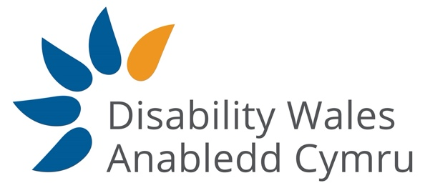
electedofficefund@disabilitywales.org

