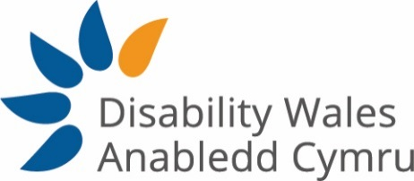

Person Specification
The post holder must be a disabled person

 | Essential | Desirable
Qualifications

Degree in a relevant subject, or equivalent experience in communications or marketing | E
Experience

A minimum of 2 years’ experience in marketing and social media experience | E
Previous experience of producing engaging materials for print and social media | E
Have an engaging, proactive and creative approach to content creation | E
Experienced in writing, editing and proofreading and producing engaging materials for print and social media. | E
Experience in design and video editing
Experienced with using Google Analytics and web Content Management Systems | E
Experienced in writing and updating website copy using CMS | E
Previous experience of working in the Third Sector |  | D
Knowledge

Knowledge of using Eventbrite, Mail Chimp and Survey Monkey | E
IT literate: knowledge of using Microsoft Office and web based applications including email, e-marketing, online surveys, e-discussion groups | E
Knowledge of working within the Charity Sector and the associated policies and procedures |  | D
Skills

Ability to utilise all social media platforms and web applications to support marketing activity and corporate image | E
Ability to adopt a motivated, committed and flexible approach to duties | E
Self-motivated and able to work independently | E
Ability to manage competing demands with good organisational skills | E
Ability to work as a team member and on own initiative | E
Ability to work to deadlines | E
Ability to prioritise workload | E
Ability to work creatively, make routine decisions and problem solve with limited resources | E
Welsh Language Skills |  | D
Values/Commitment to

The Social Model of Disability | E
DW’s mission, aims and objectives and values | E
Equality, Diversity and Human Rights | E
An Inclusive Society | E
The cultural importance of the Welsh Language | E
A team working approach across DW | E
Good working practices, e.g. professionalism, confidentiality, punctuality, adaptability | E
Continuous professional development | E
General Criteria

Support the ongoing development of DW membership through all communication channels | E
Willingness to travel throughout Wales and beyond, which may require overnight stays in line with the duties of the post. | E

