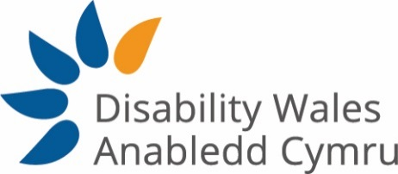

Person Specification
The post holder must be a disabled person
 | Essential | Desirable
Qualifications

Degree or equivalent experience | E
Experience

Experience of policy development in a complex environment | E
Experience of writing policy documents of varying length and for a variety of audiences | E
Experience of lobbying and campaigning at government level and an understanding of political processes and how to influence | E
Relevant experience in working collaboratively with disabled people and their organisations | E
Experience of facilitating a diverse range of stakeholders contributing to the development of good policy and practice | E
Experience of using community development/capacity building techniques | E
Experience in undertaking and delivering research studies | E
Experience of producing evaluation reports | E
Previous experience of working in the Charity Sector |  | D
Knowledge

Understanding of the political and policy making process in Wales and levers for influencing change | E
Understanding of co-production as a method of joint working in relation to policy and practice | E
Drafting funding bids and tenders | E
Knowledge of working within the Third Sector and the associated policies and procedures |  | D
Skills

Ability to analyse complex policy issues, identify key issues for DW and develop messages for influencing and campaigning | E
Ability to communicate policy messages to a range of audiences through a variety of channels | E
Ability to plan, manage and deliver projects and initiatives | E
Ability to adopt a motivated, committed and flexible approach to duties | E
Ability to build relationships with internal and external stakeholders | E
Self-motivated and work independently when required | E
Ability to manage competing demands with good organisational skills | E
Ability to work as a team member and on own initiative | E
Ability to work to deadlines | E
Ability to prioritise workload | E
Welsh Language Skills |  | D
Values/Commitment to

The Social Model of Disability | E
DW’s mission, aims and objectives and values | E
Equality, Diversity and Human Rights | E
An Inclusive Society | E
The cultural importance of the Welsh Language | E
A team working approach across DW | E
Good working practices, e.g. professionalism, confidentiality, punctuality, adaptability | E
Continuous professional development | E
General Criteria

Willingness to travel throughout Wales and beyond, which may require overnight stays in line with the duties of the post | E

